***PROJECT CREATION USING TDM PORTAL***

* Log in to TDM Portal using <https://localhost/TestDataManager/index.html>
* Provide Username and Password to Login

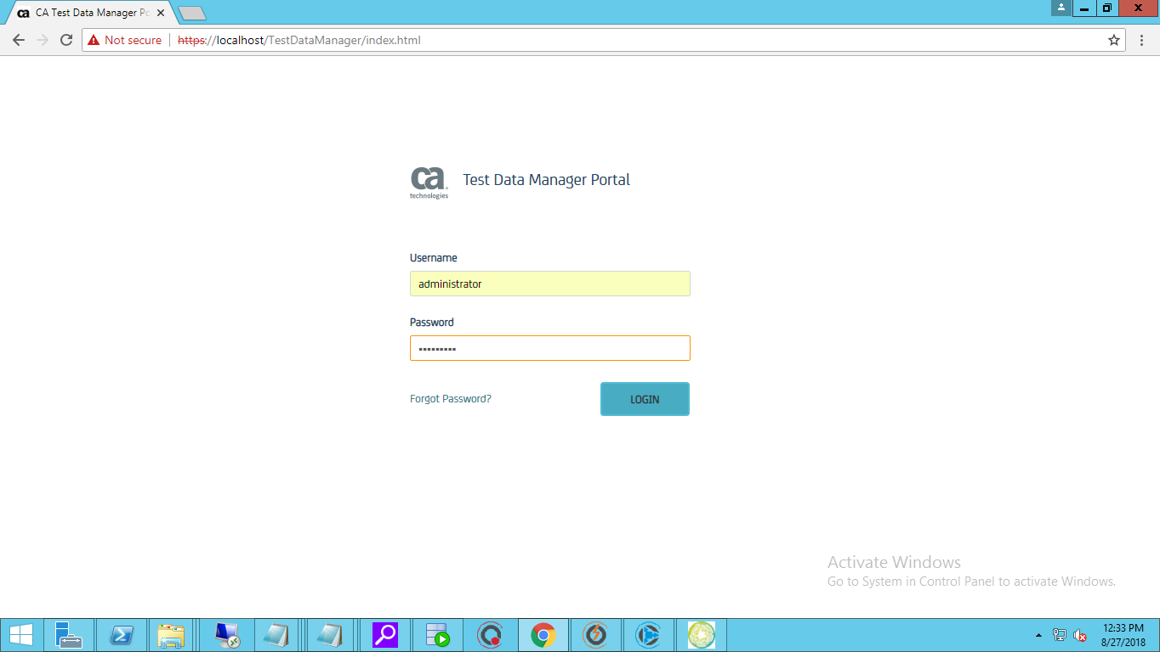

* On Successful Login you will be presented with the following screen

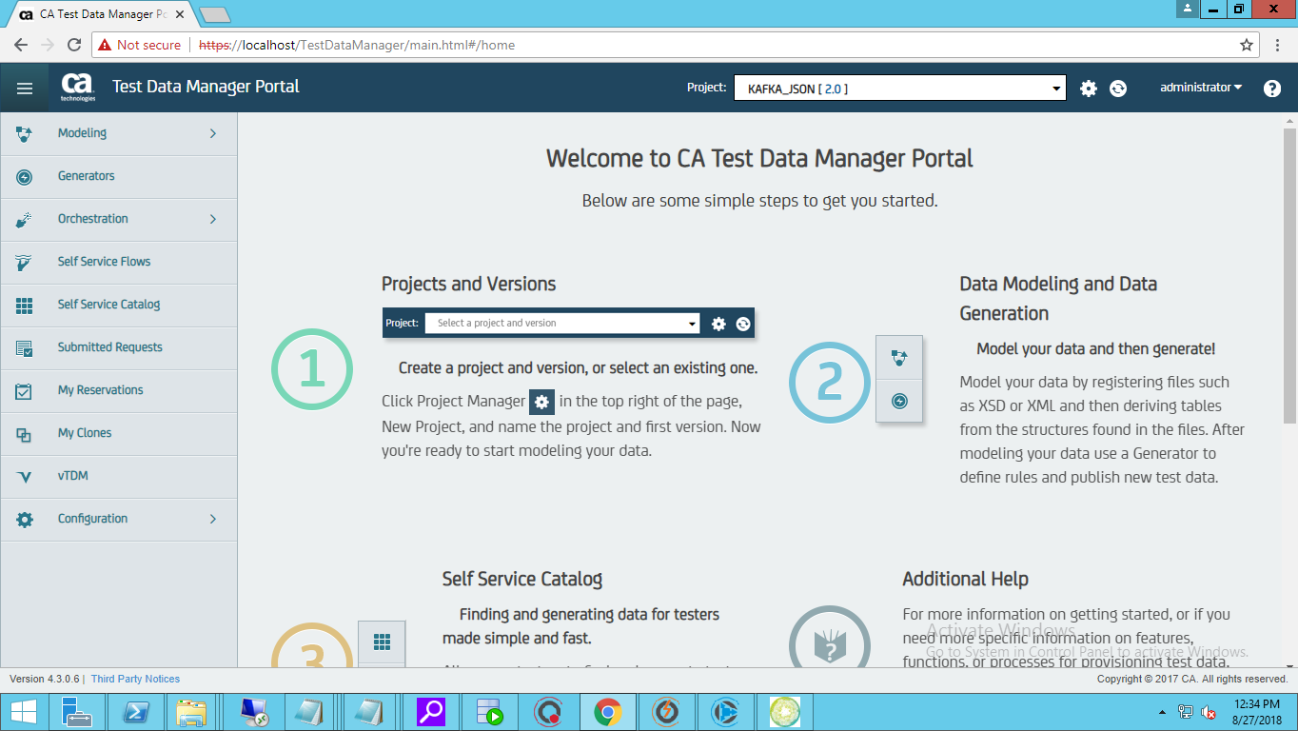

* Click on the Project Manager Icon (Gear Icon) to see all the existing projects.

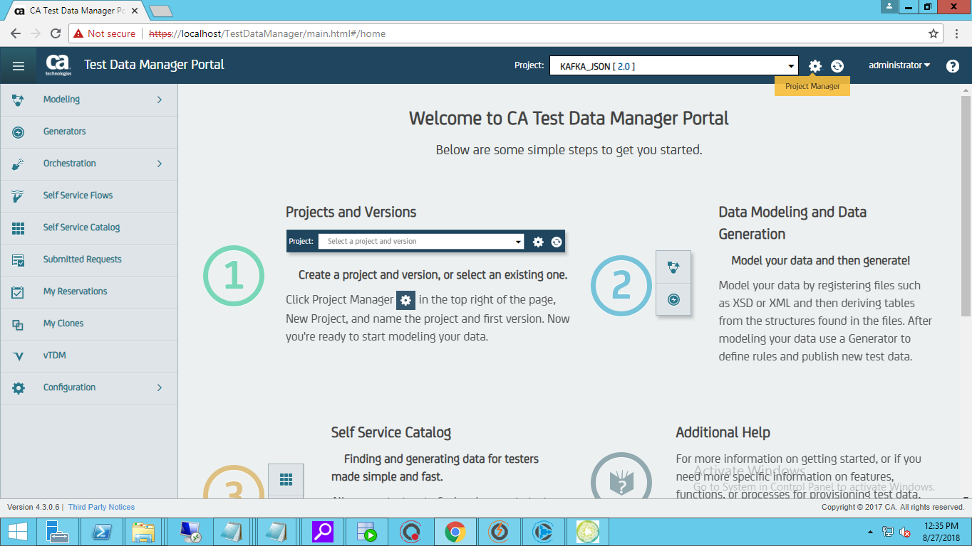

* Click On New Project

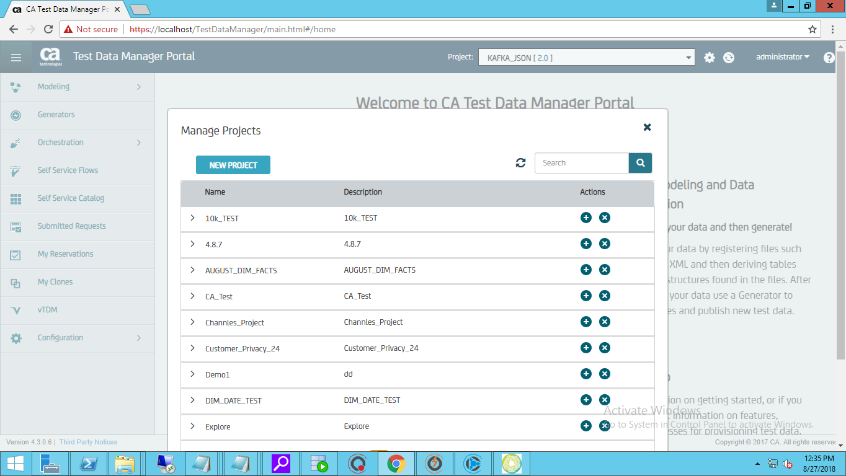

* You will be prompted to the following screen

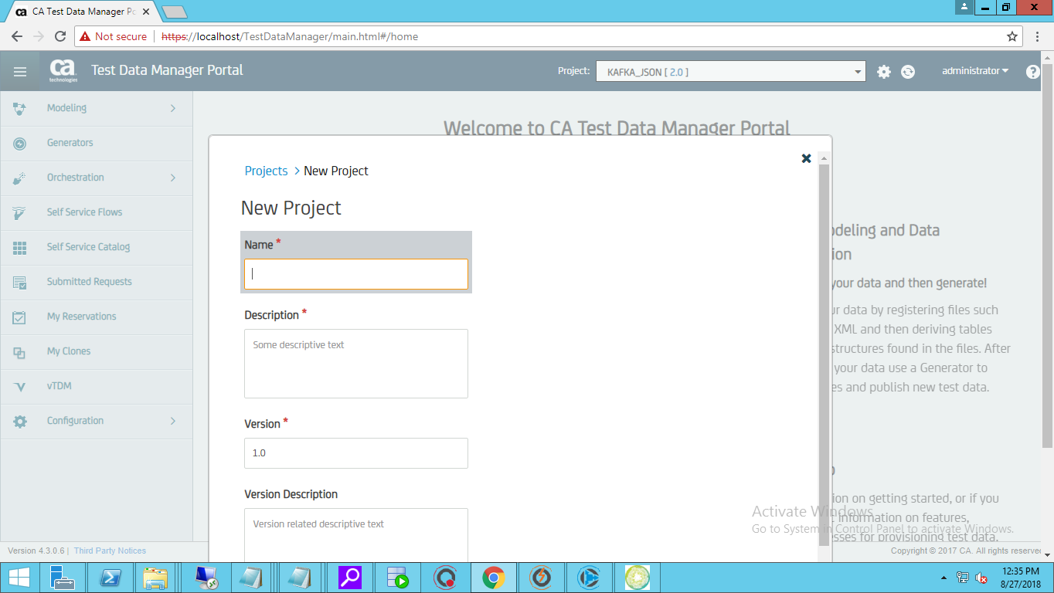

* Provide all the Details as below

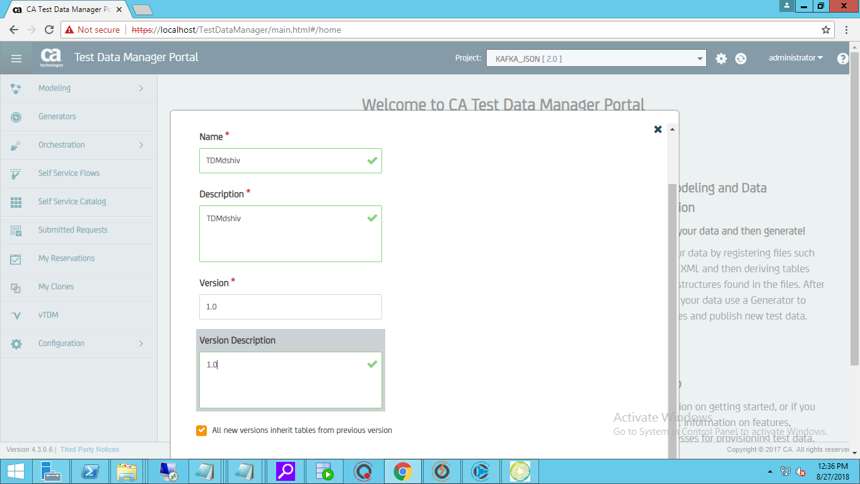

* Click on Save.

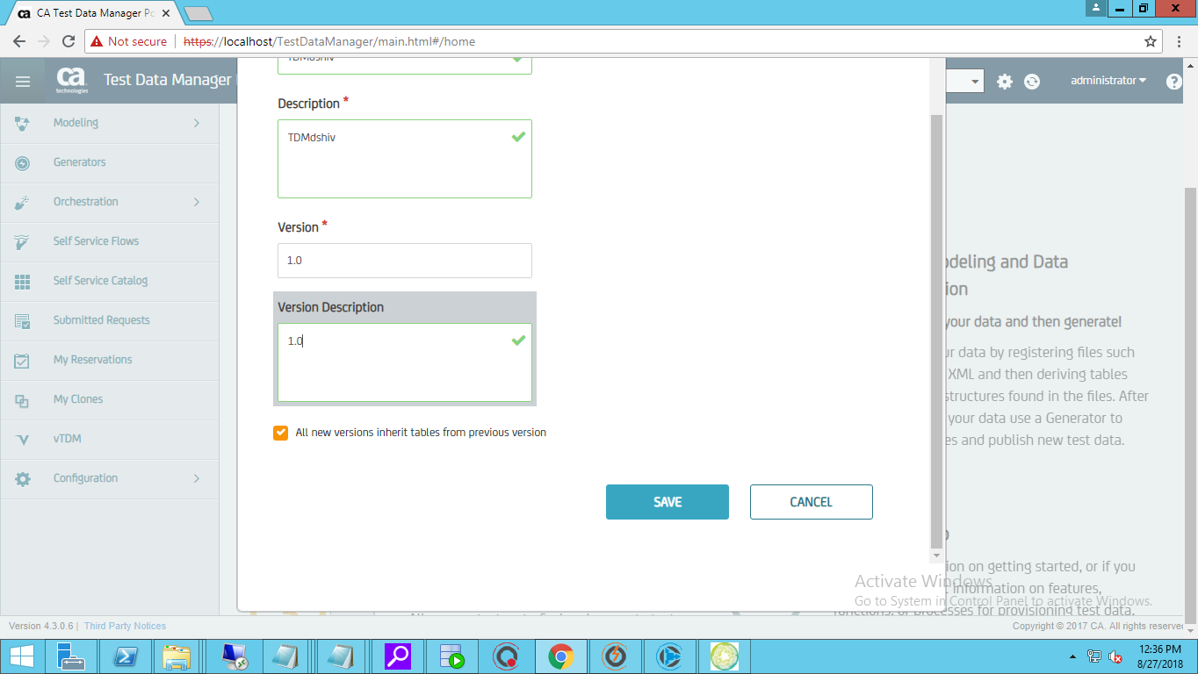

* You can see the Project Created in the list

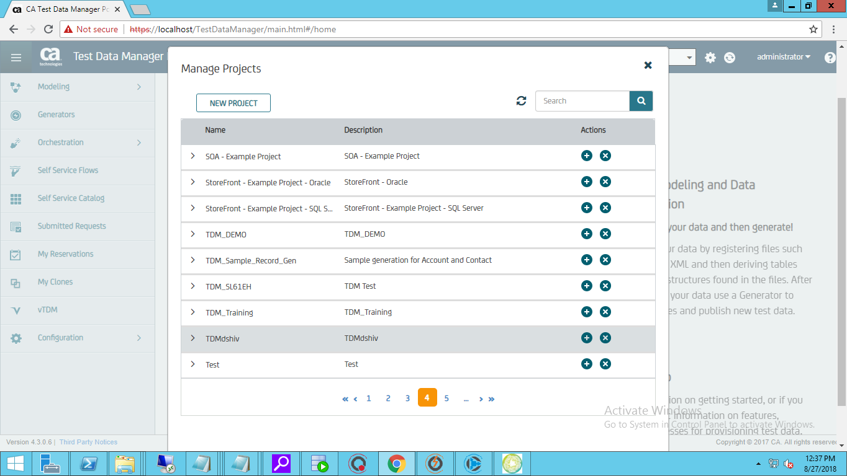

***PROFILE CREATION FROM TDM PORTAL***

* Log in to TDM Portal
* Click on Configuration
* Click on Connection Profiles
* Here you can view the existing/Created Profiles

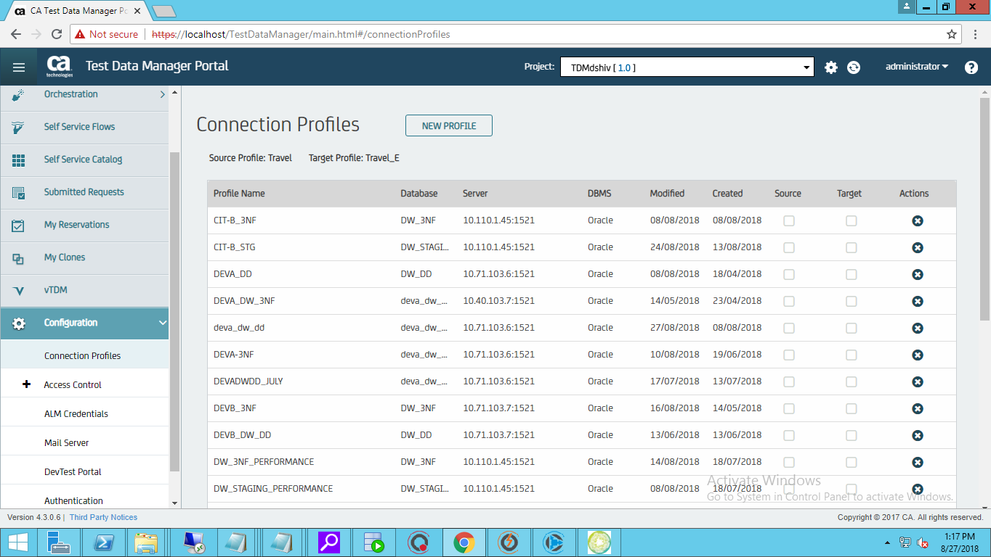

* Click on New Profile

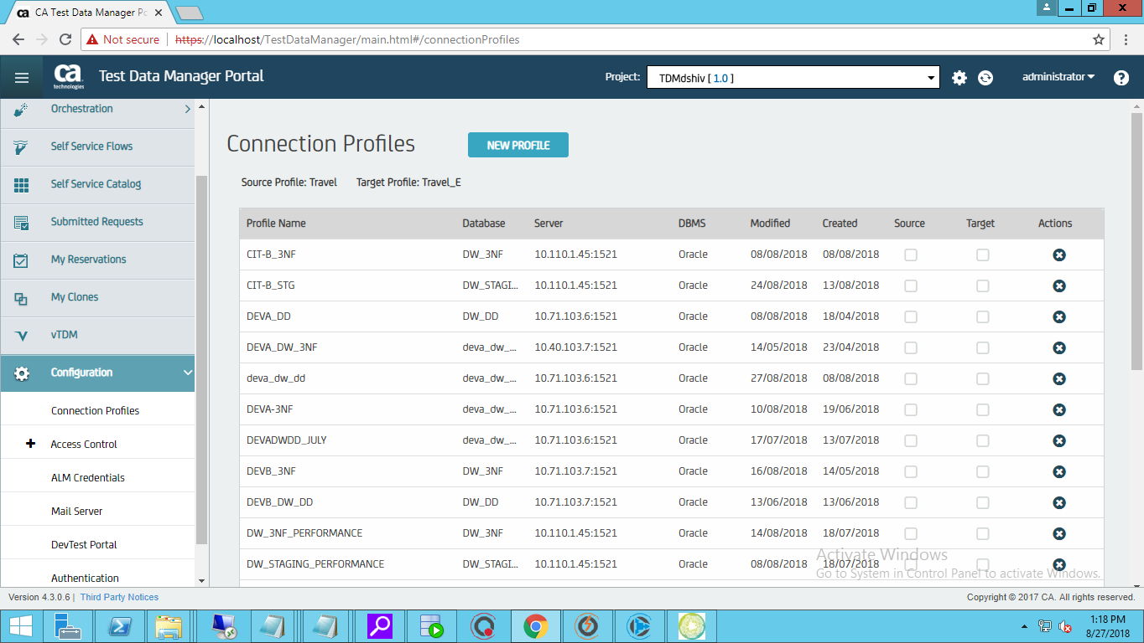

* Choose the type of DB you want to Connect to

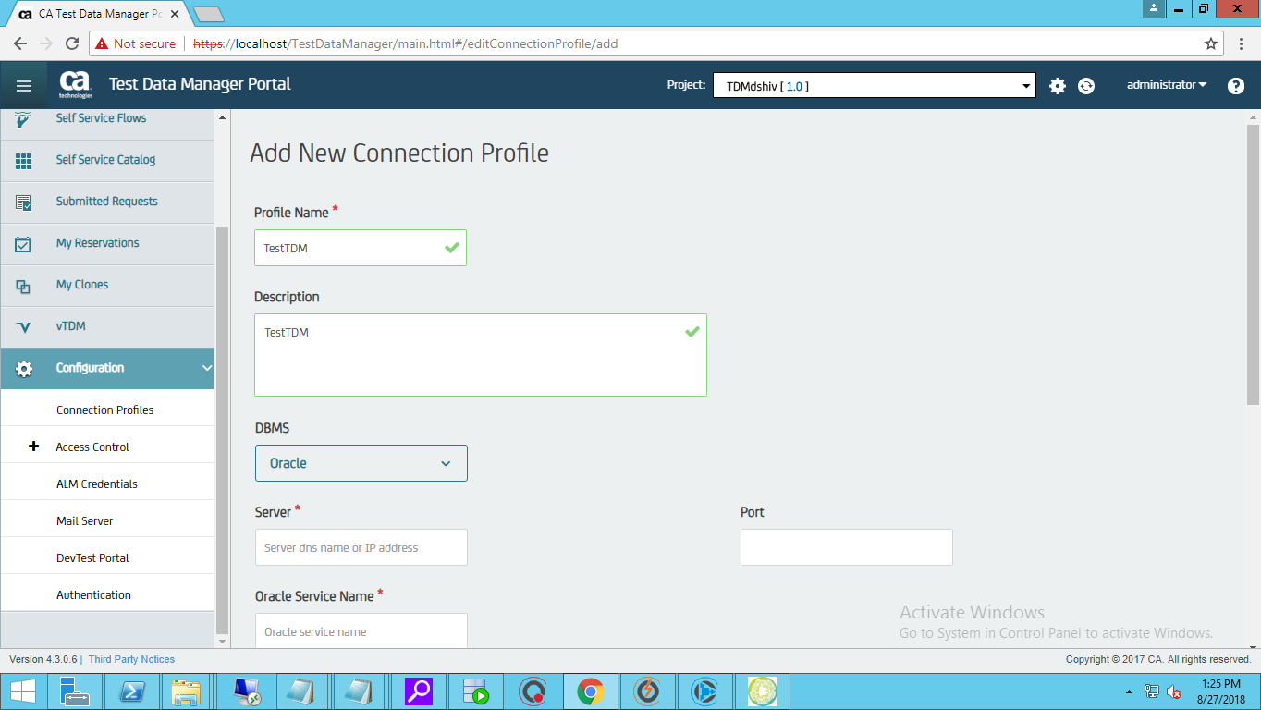

* Provide the Mandatory Fields

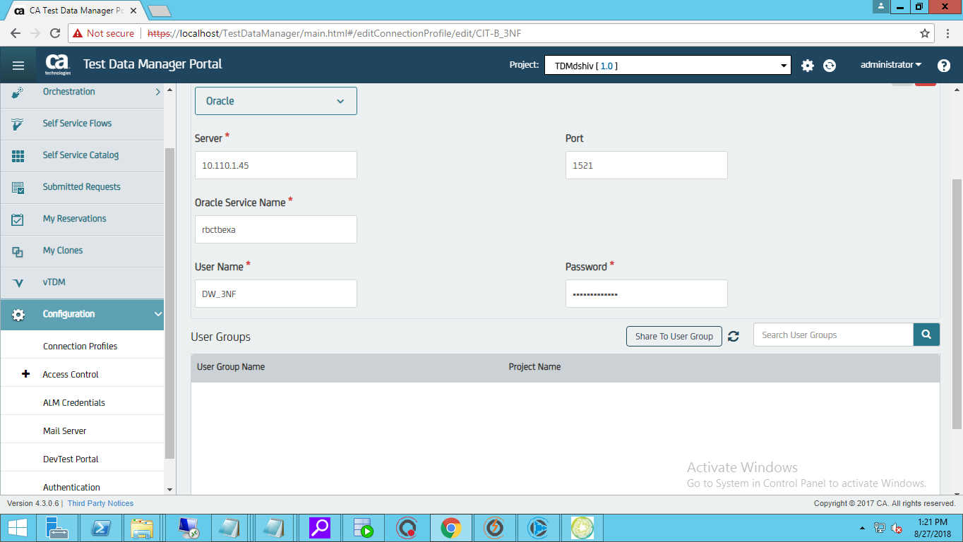

* Test the Connection Details provided

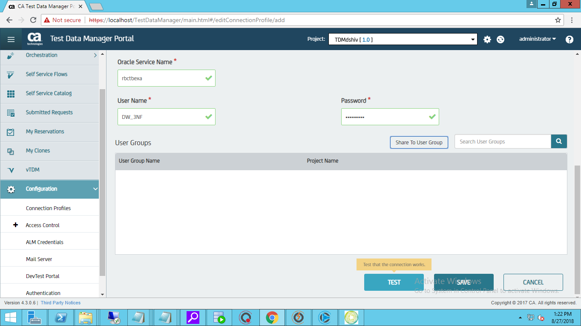

* If the details provided is correct you will get a message “The Connection works OK” as show below.

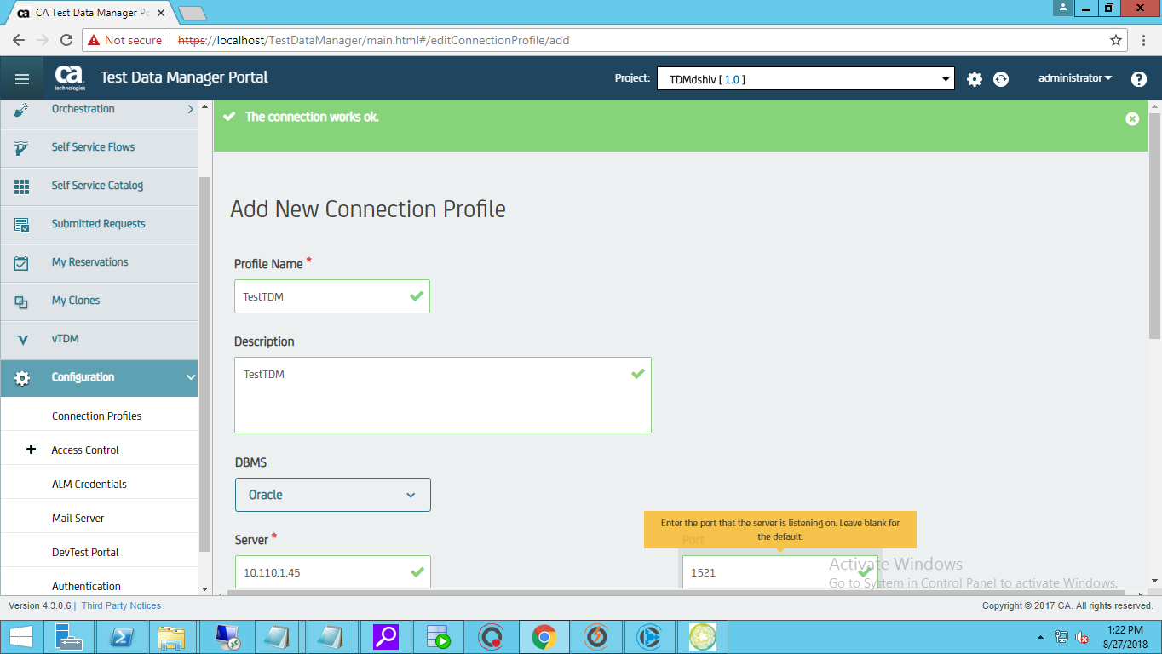

* Save the Connection details.

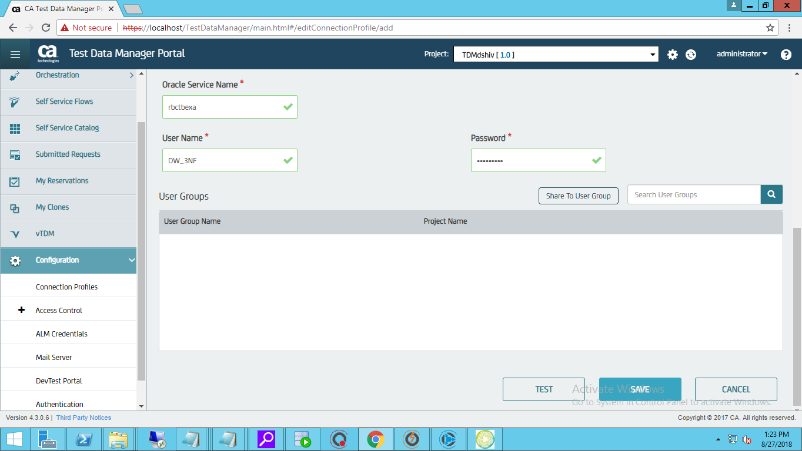

* Click on configuration🡪 Connection Profiles 🡪 Here you can see the profile created successfully

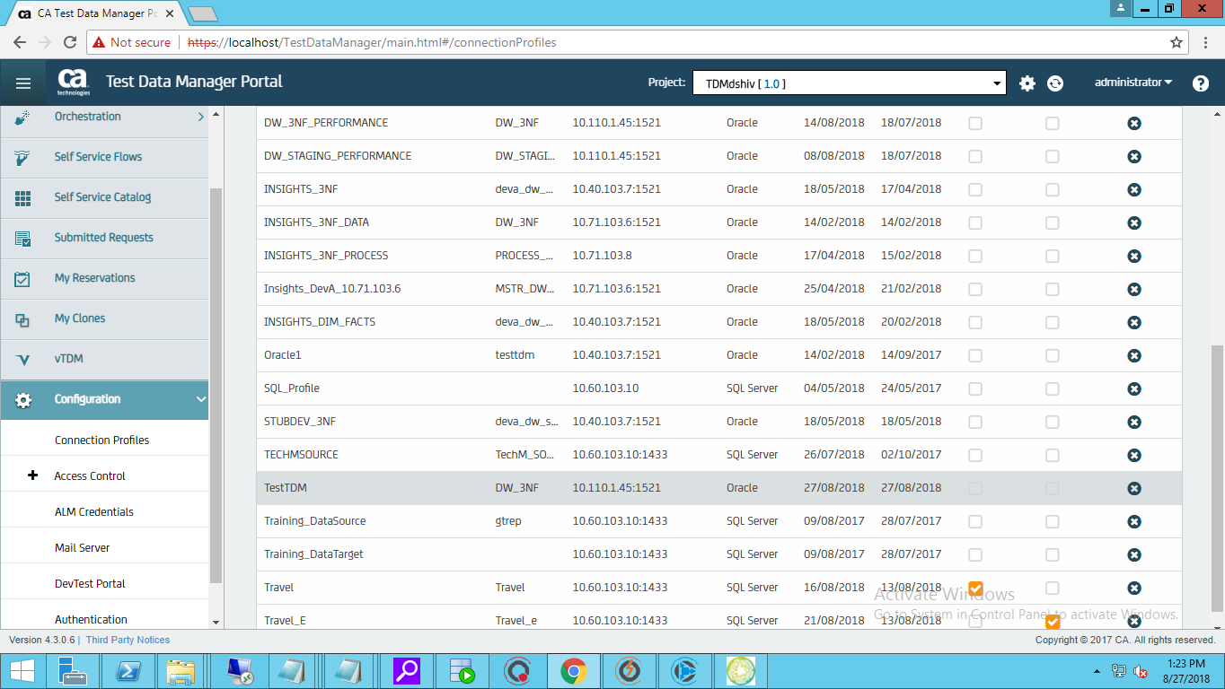

***SYNTHETIC DATA GENERATION USING TDM PORTAL***

* Log in to CA TDM Portal
* Click on Modelling🡪Objects🡪Register New Objects🡪Tables

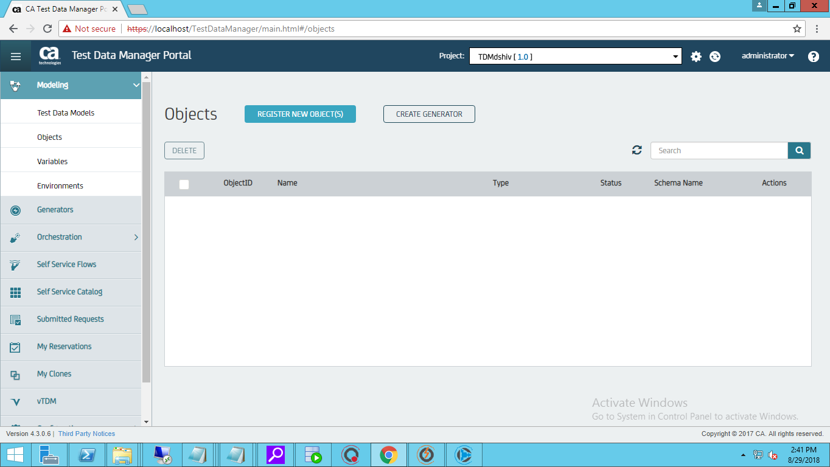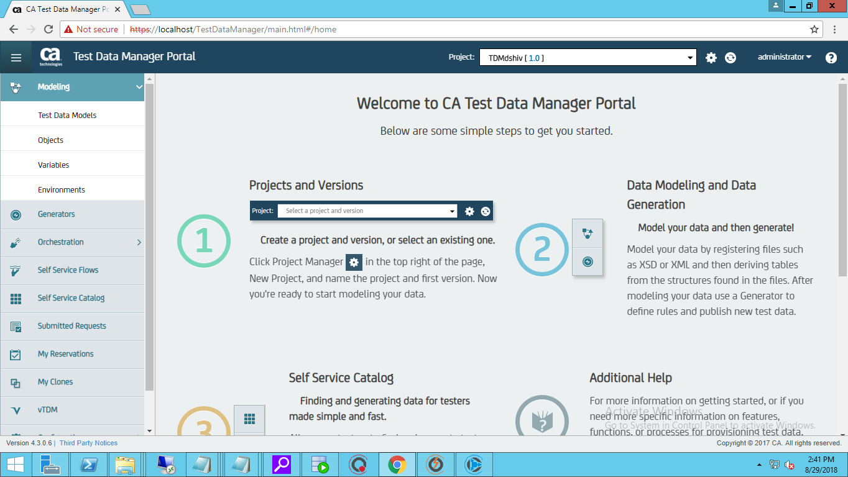

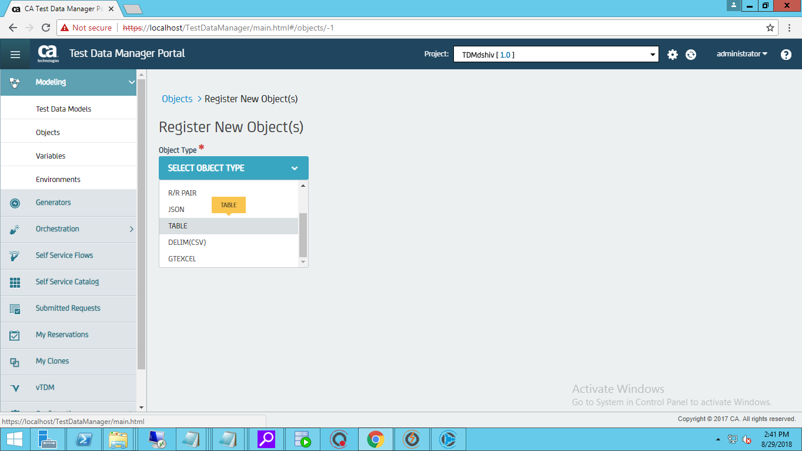

* Provide Connection Profile and Schema details

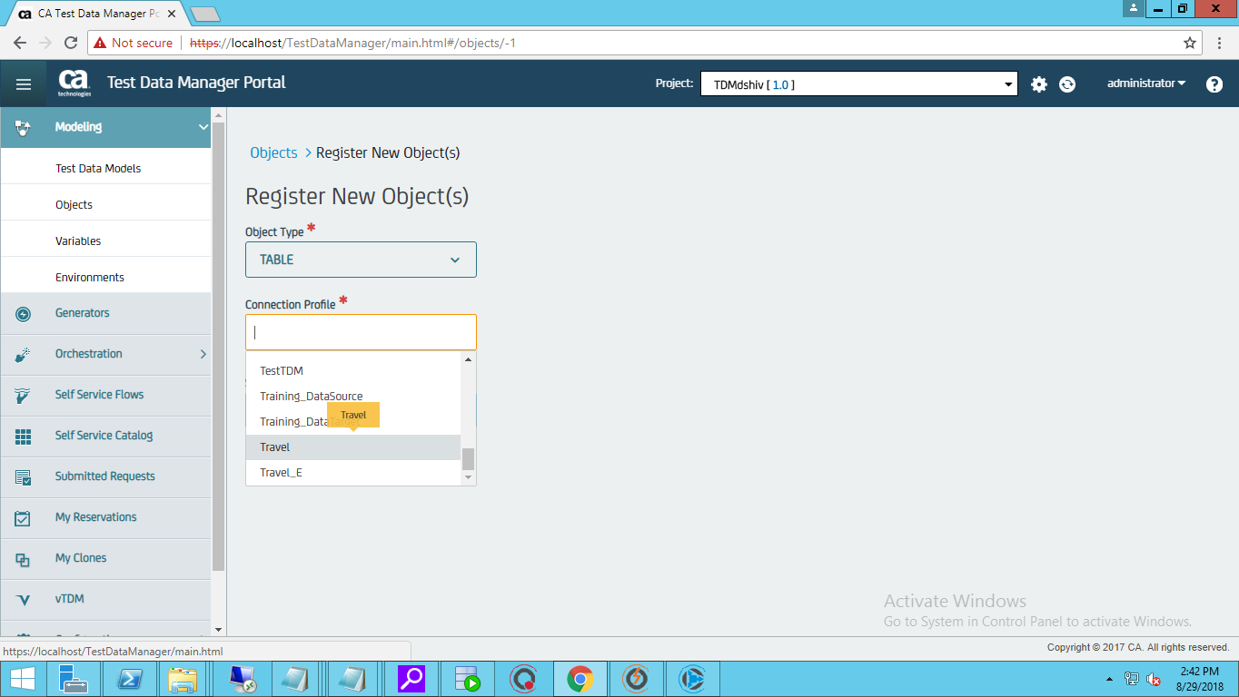

* If the details are valid all the tables in the schema will appear
* Select the table for which the synthetic data has to be generated
* Click on Register

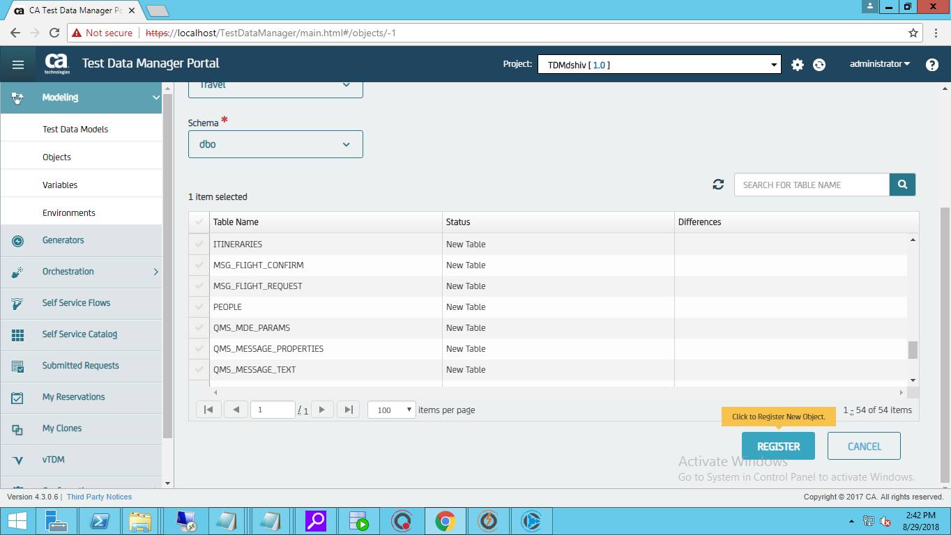

* Success Message will appear if the table is registered as shown below

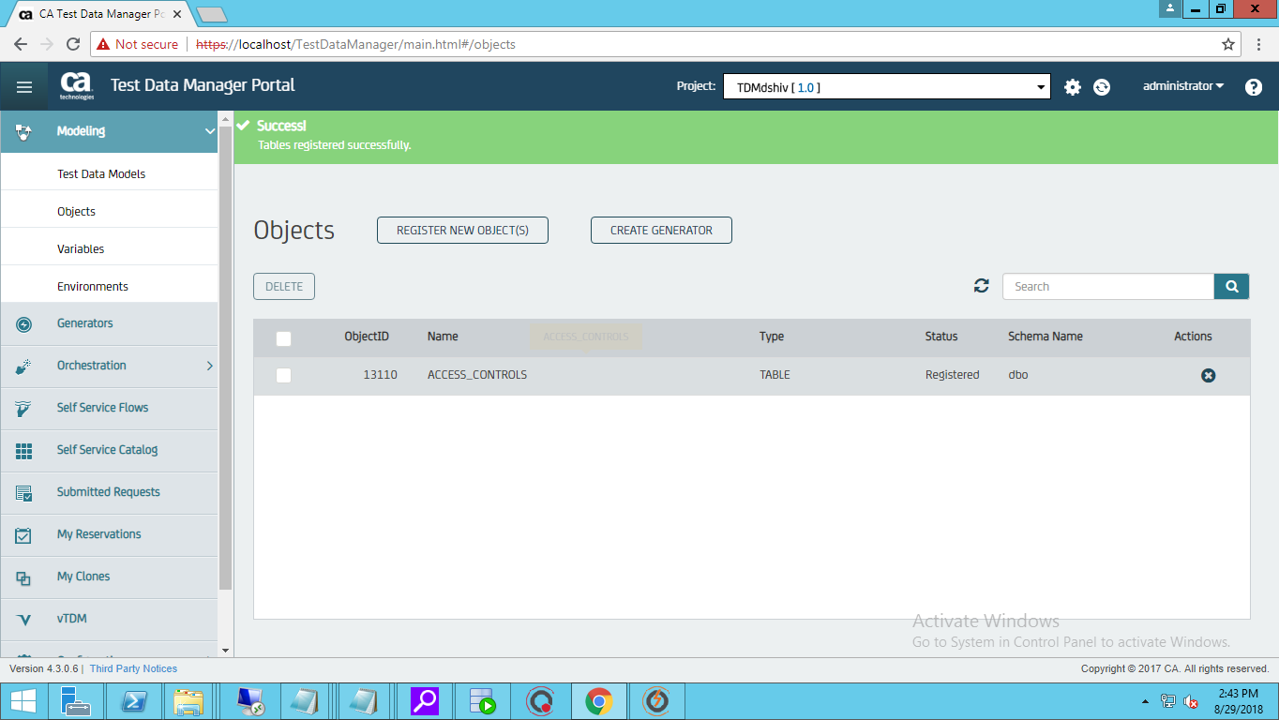

* Next is to create Generators to create Functions/Rules for the column

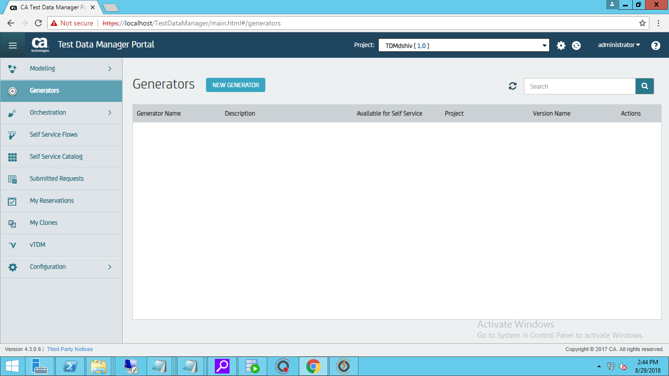

* Provide the details for the generator

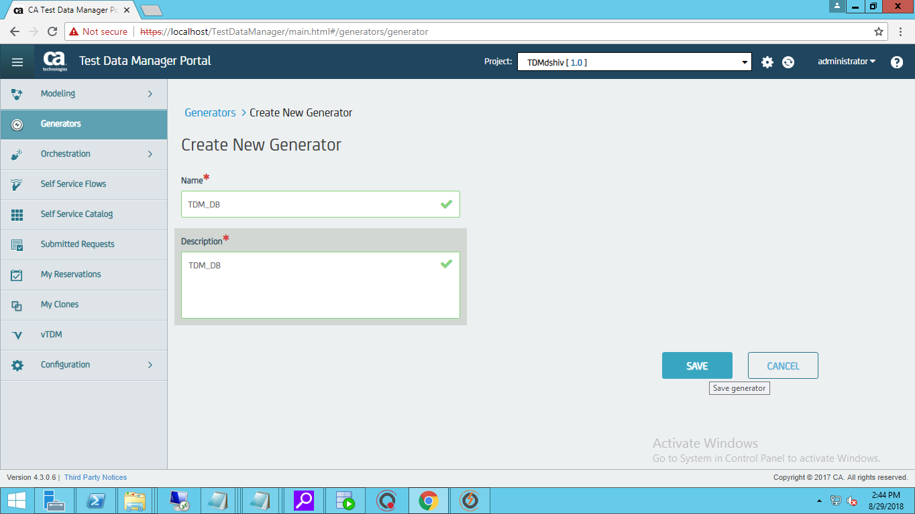

* Click on the generator created

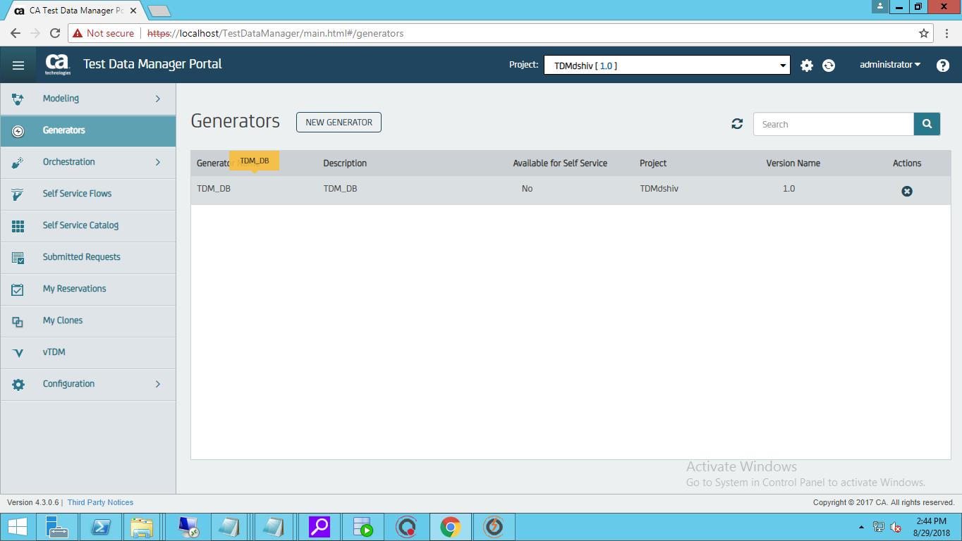

* From this we will get to know the table list which are registered
* Select the Registered table

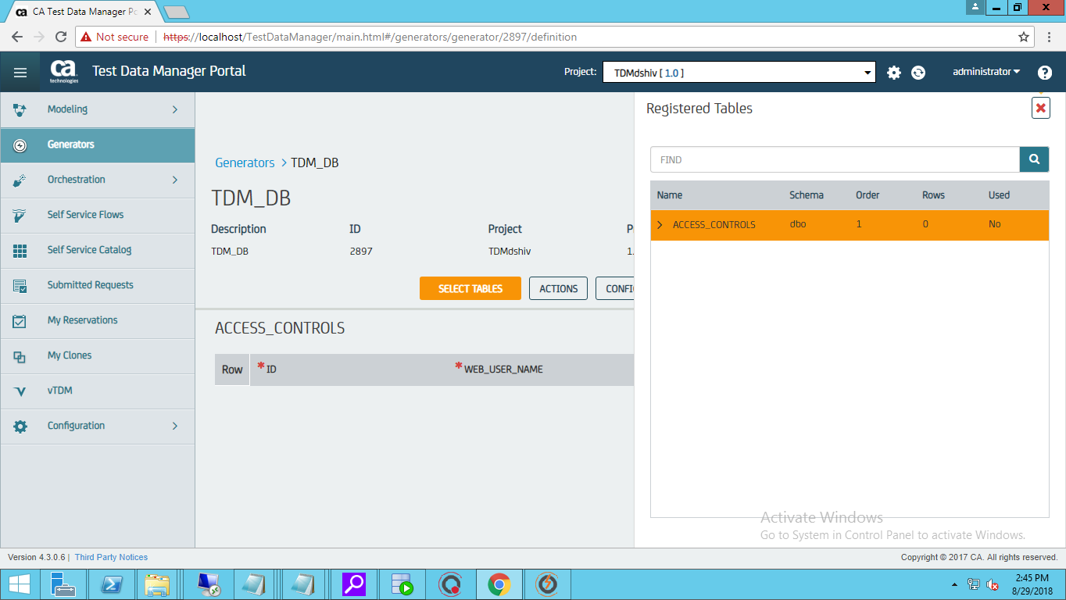

* Click on +r Symbol to add a row for adding rules to the column

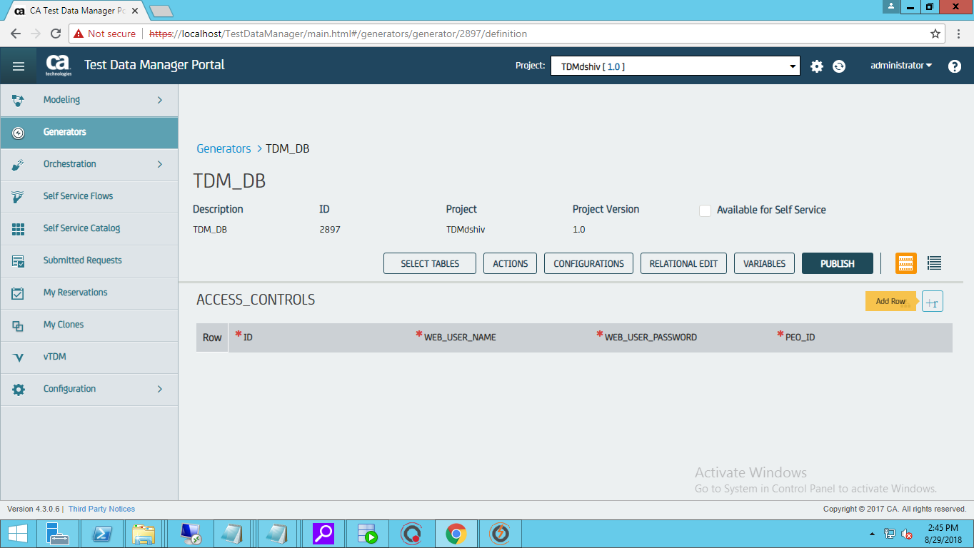

* Click on the column and the Data Painter Button and create the required Rules for the column

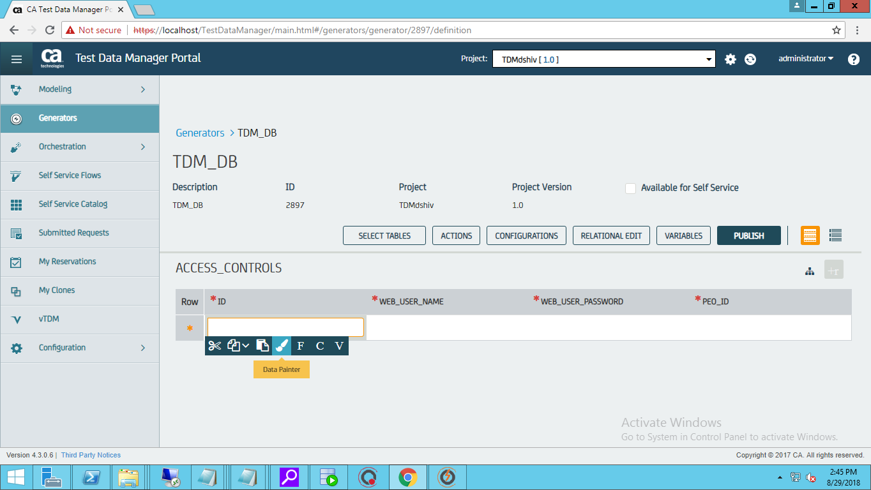

* After creating the rules click on publish

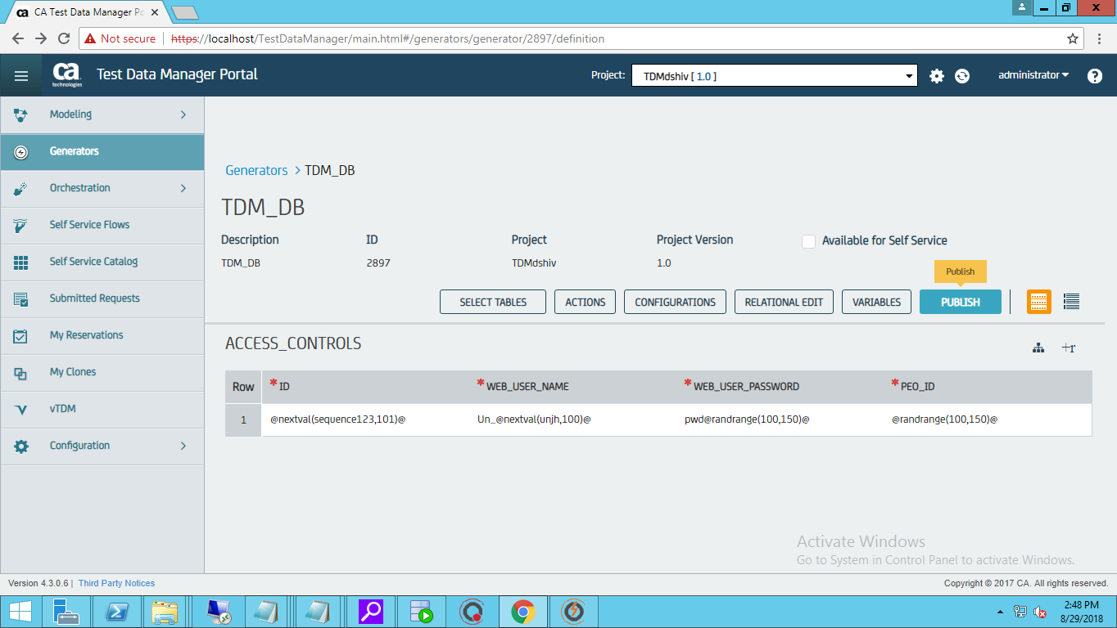

* Select the options as shown below with the repeat count for number of rows to be published

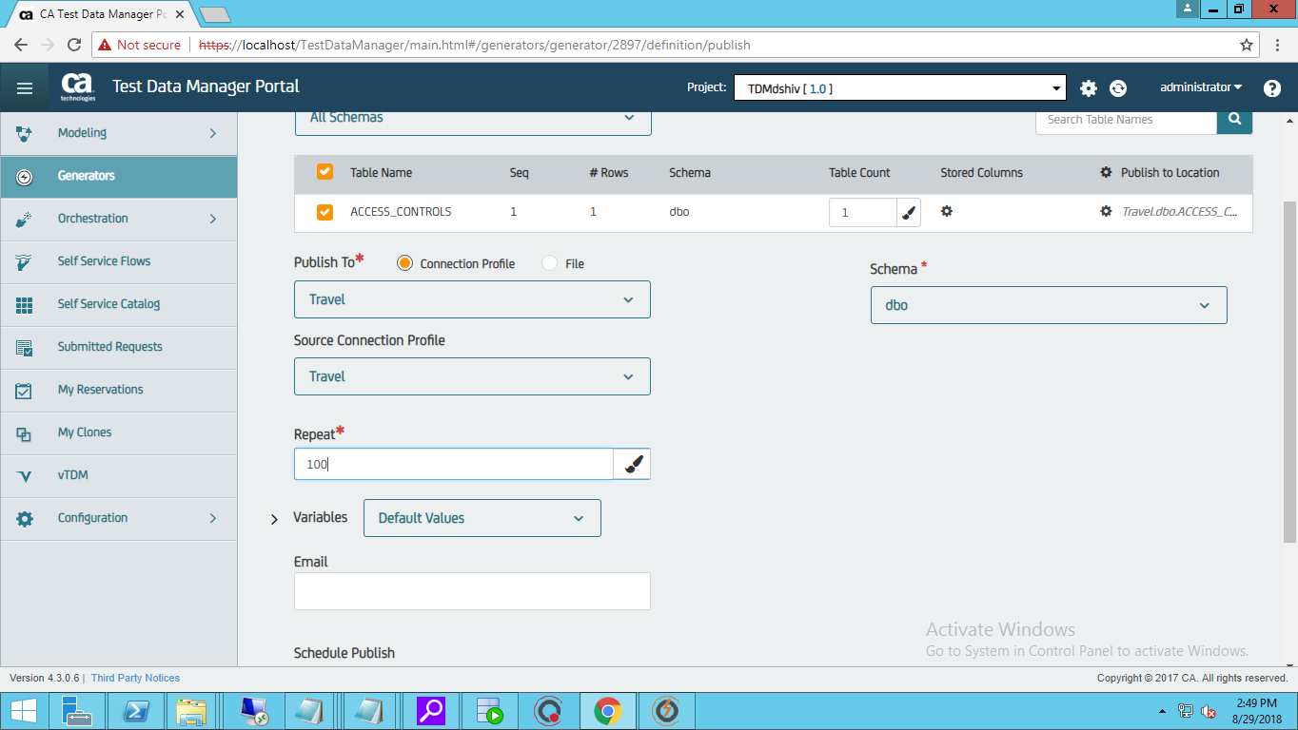

* Click on Publish

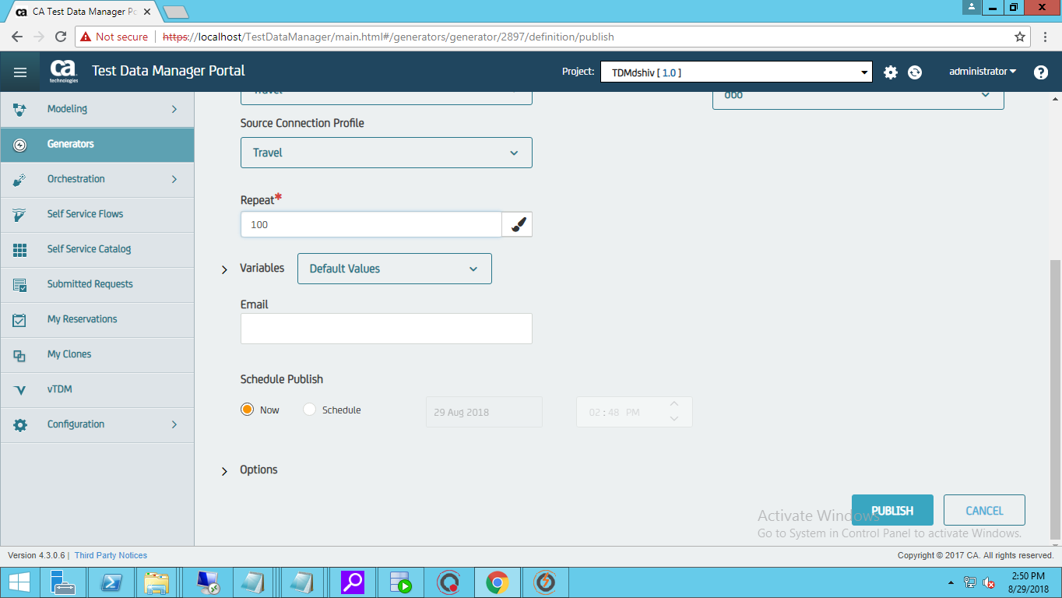

* Once the rRequest is successful you will be able to see the Output by clicking the Job and also by downloading the log file.

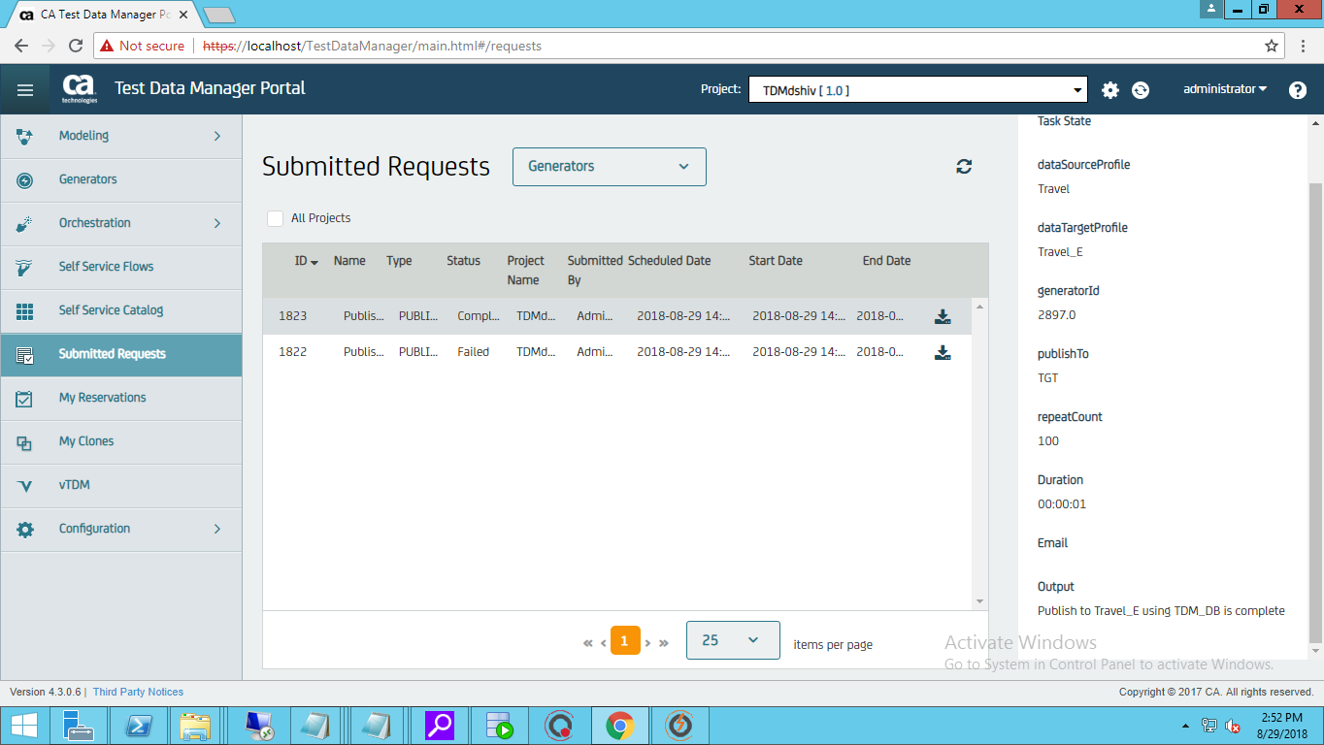

***DATA GENERATION IN CSV FILE***

* In Order to Register a CSV/Excel File
* Goto Modelling🡪Objects🡪Register New Objects🡪Choose Delim(CSV) as shown below

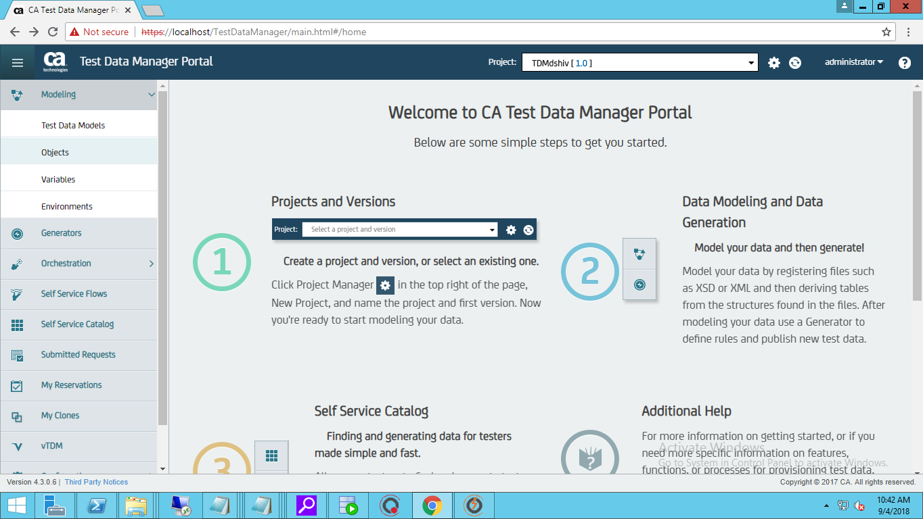 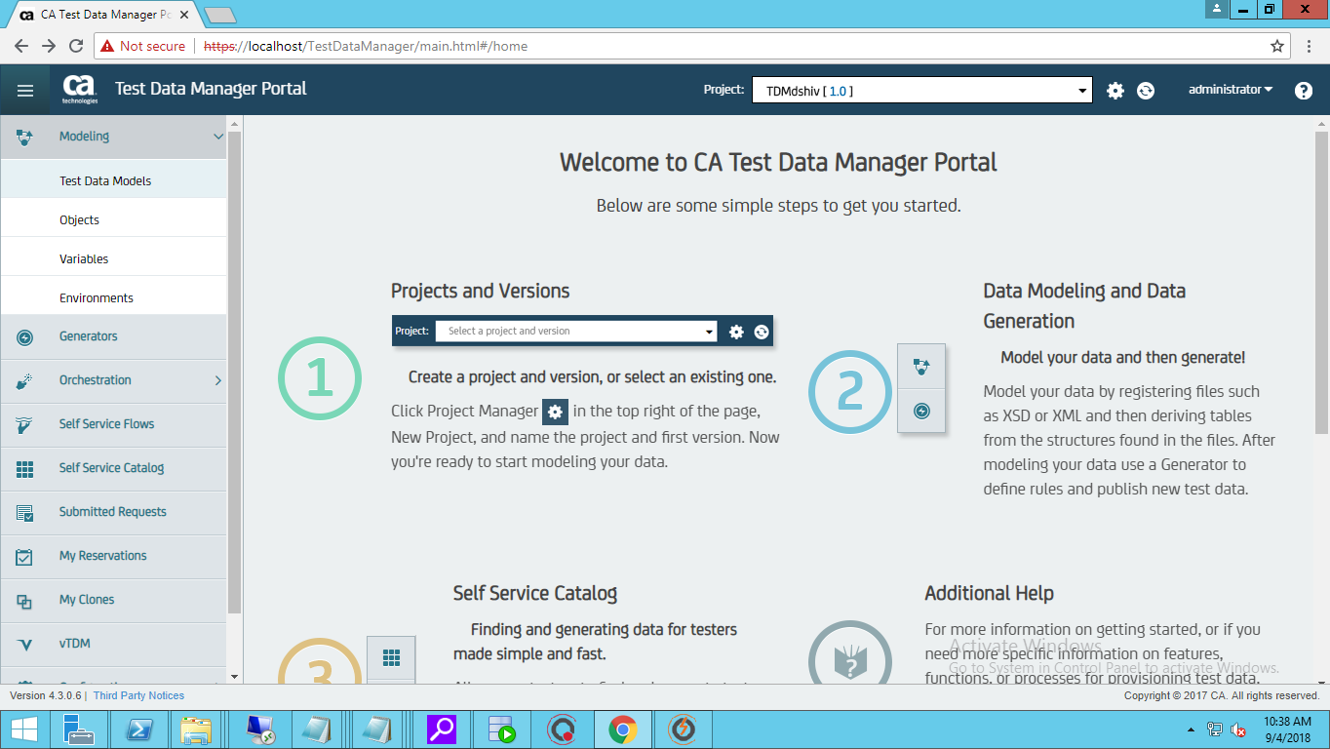

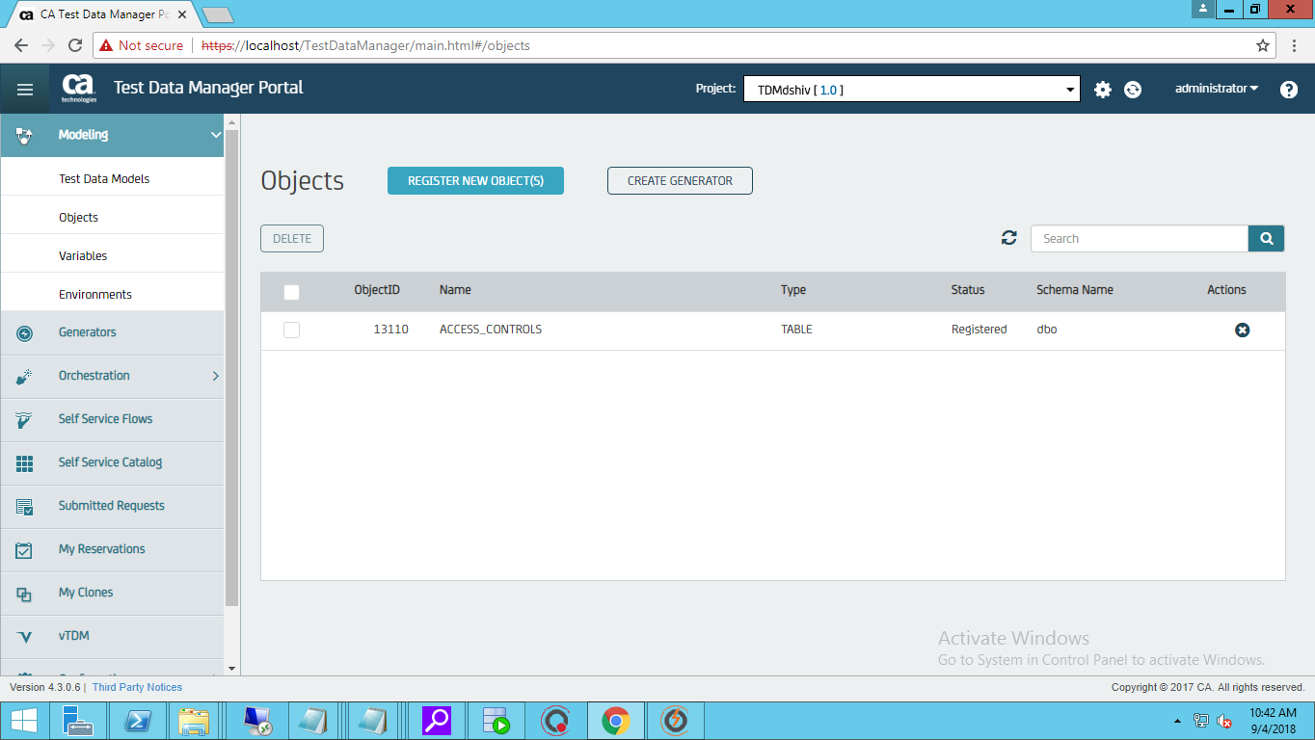

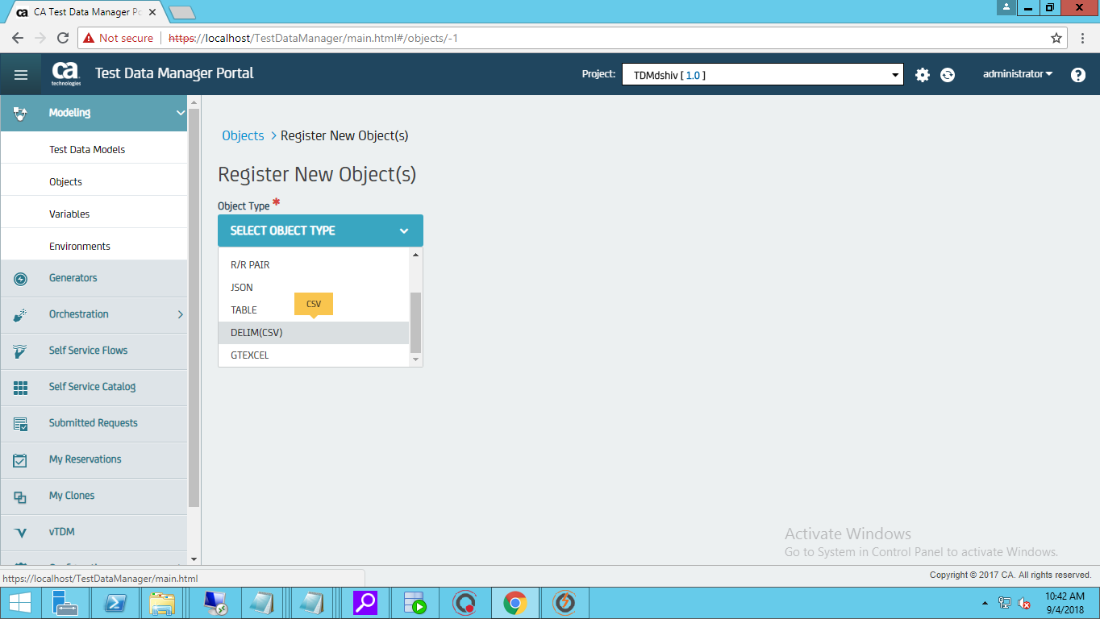

* Drag and Drop/Choose the Sample CSV/Excel File where the data has to be generated Synthetically as shown below

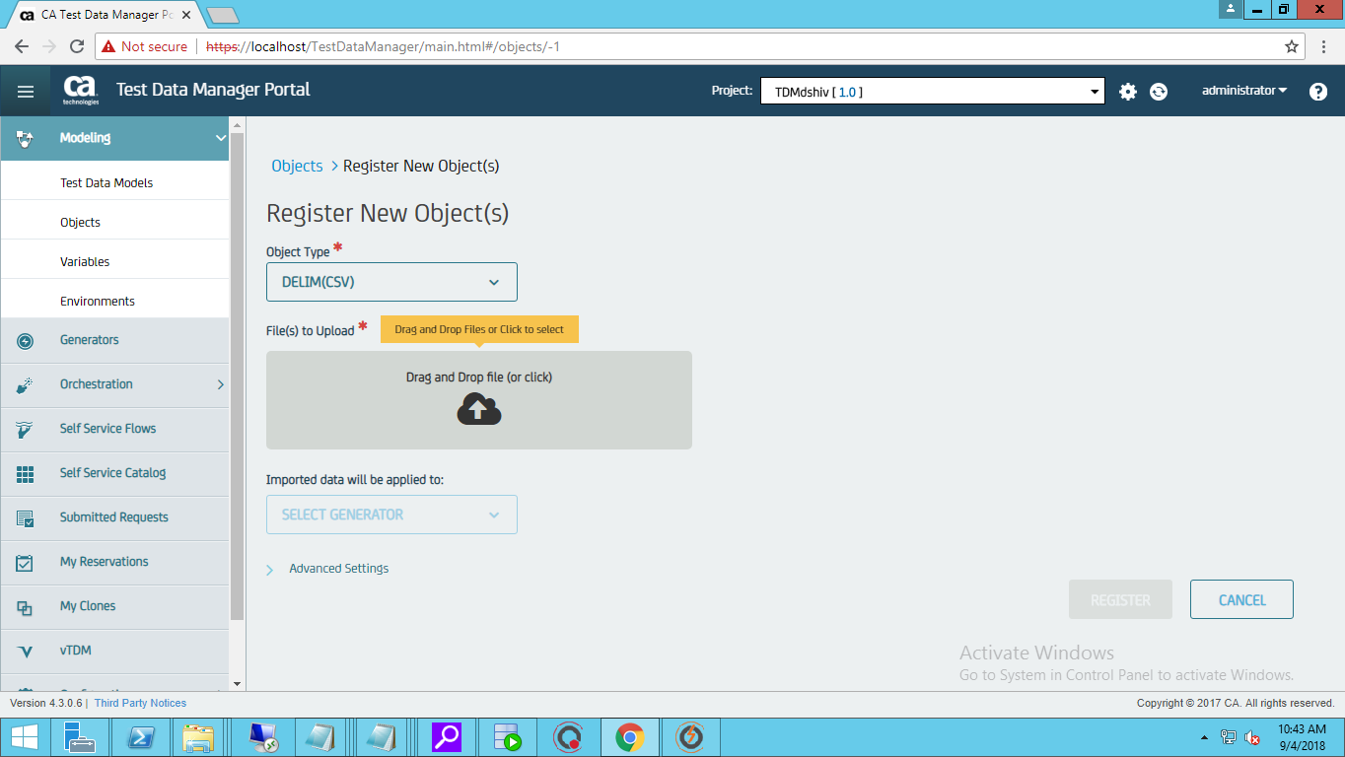

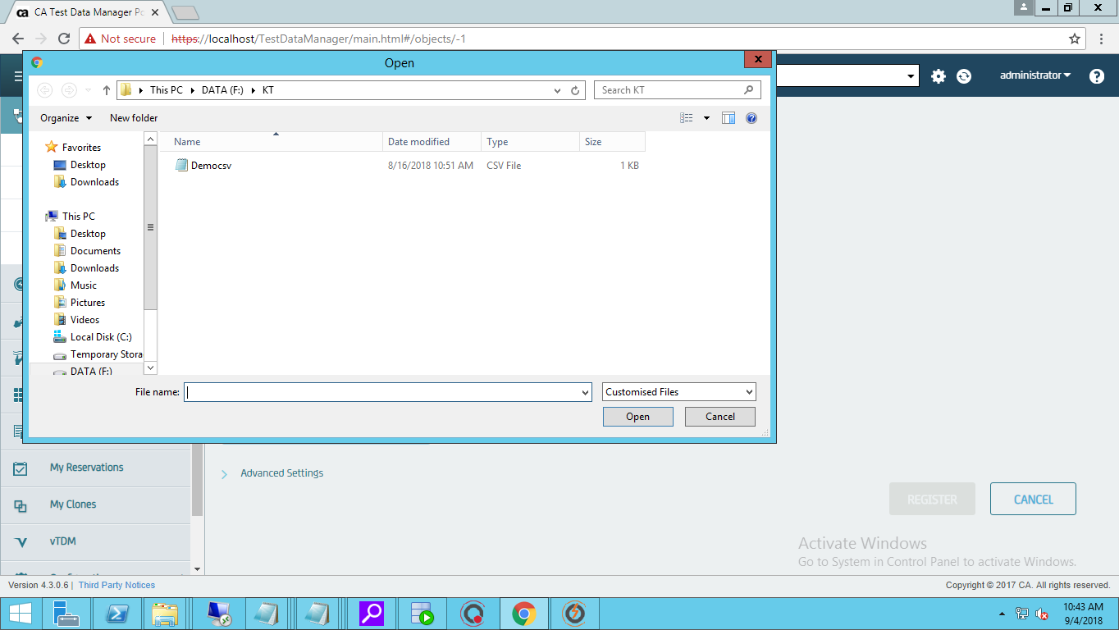

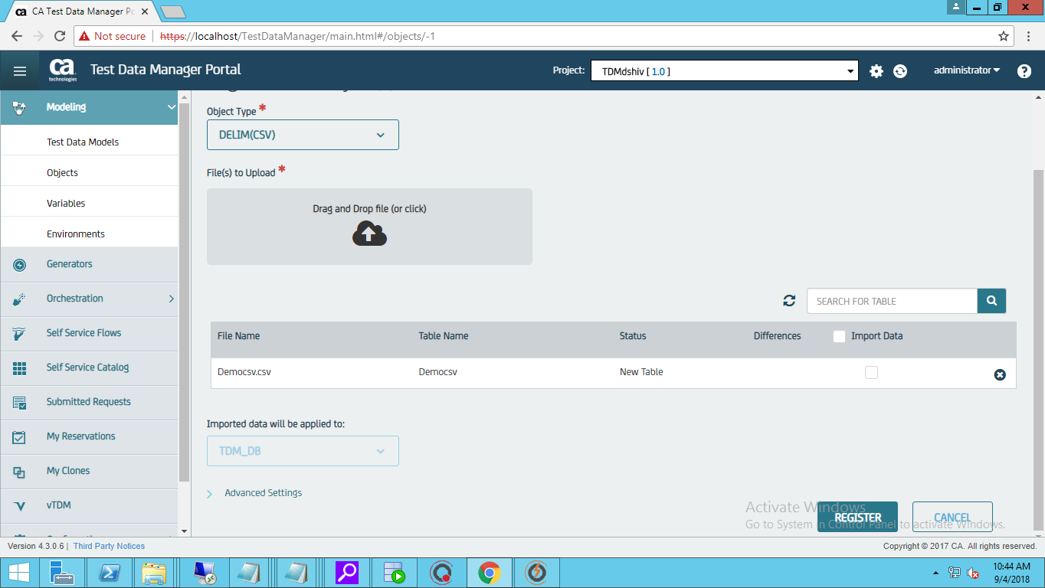 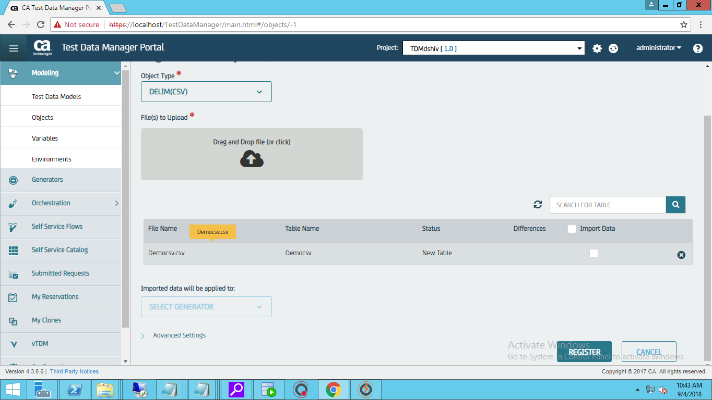

* On Successful Regsistration we will see the below Message.

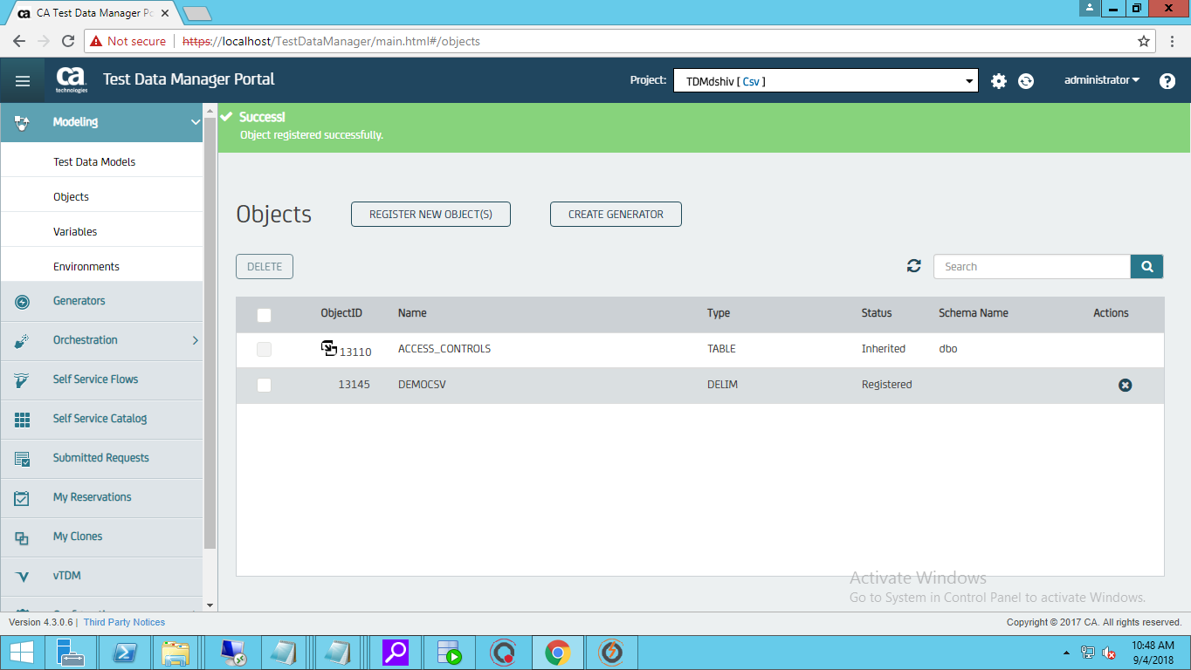

* Create a Generator if required according to the needs.

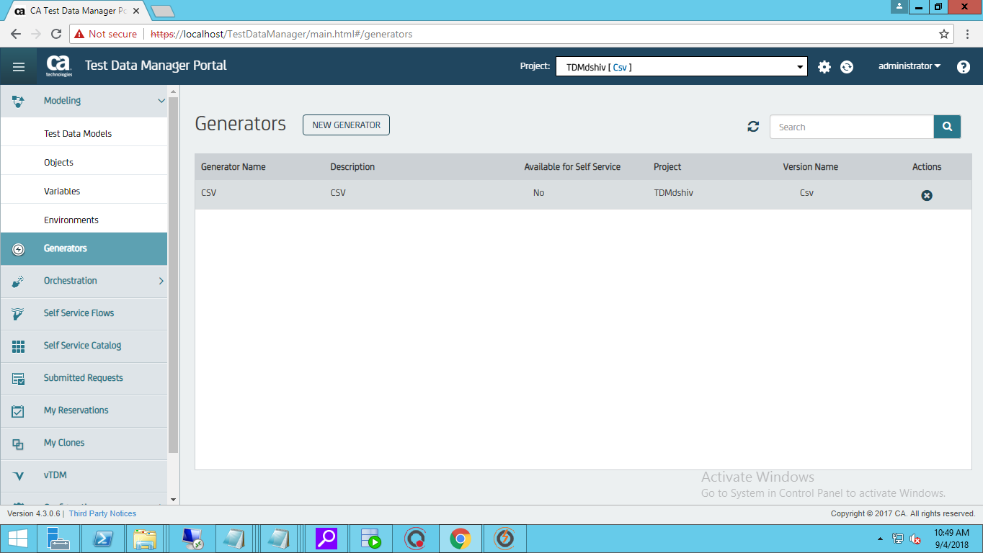

* Select the registerd CSV file and click on +r to add a row in order to write Synthetic Data generation rules/Functions.

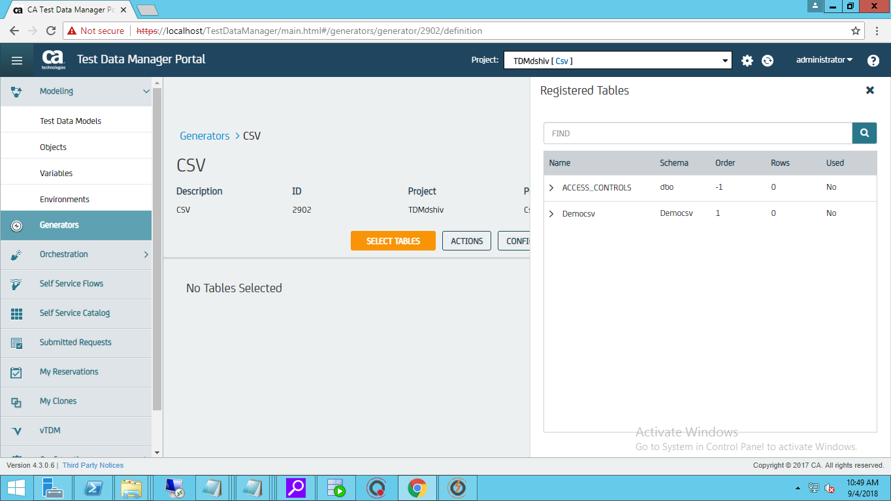

* Provide the Synthetic Data generation Rules for the columns of the CSV/Excel file

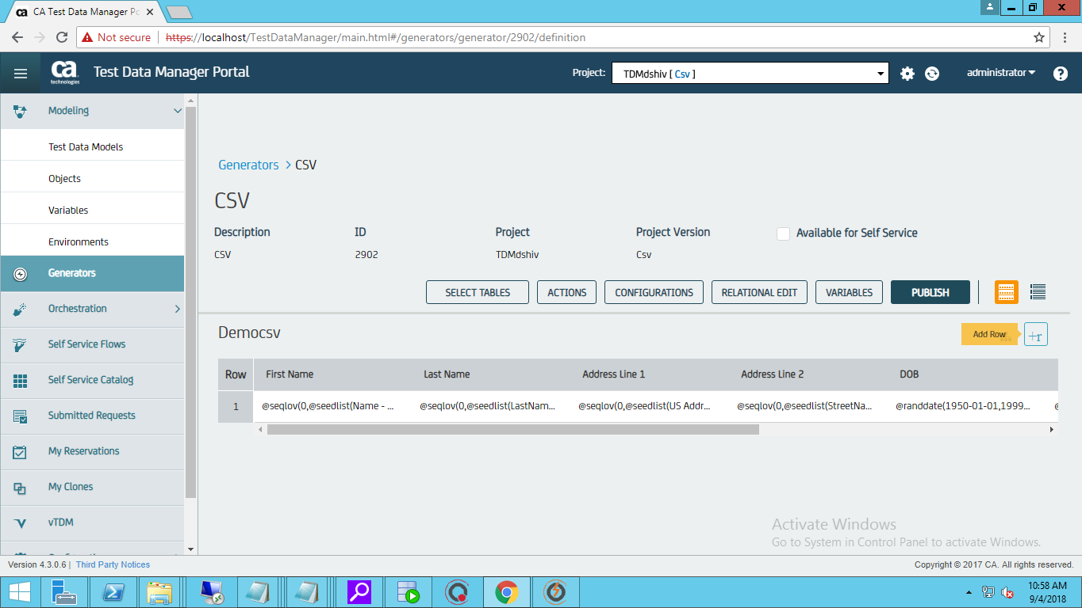

* After generating the Rules/Function Click on Publish

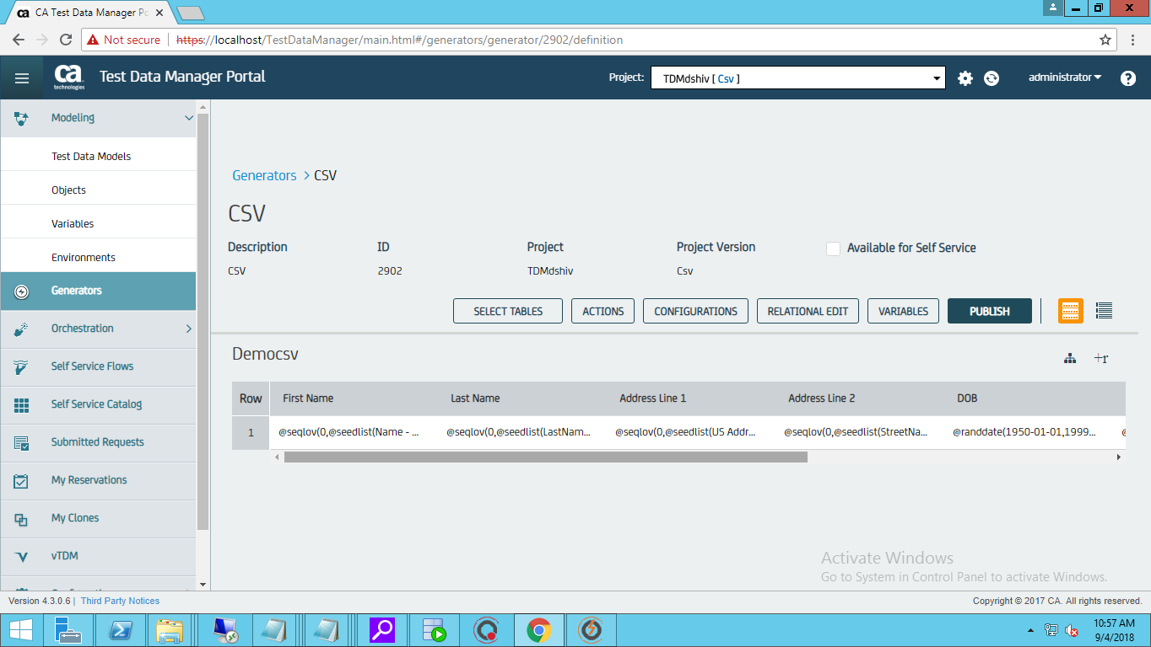

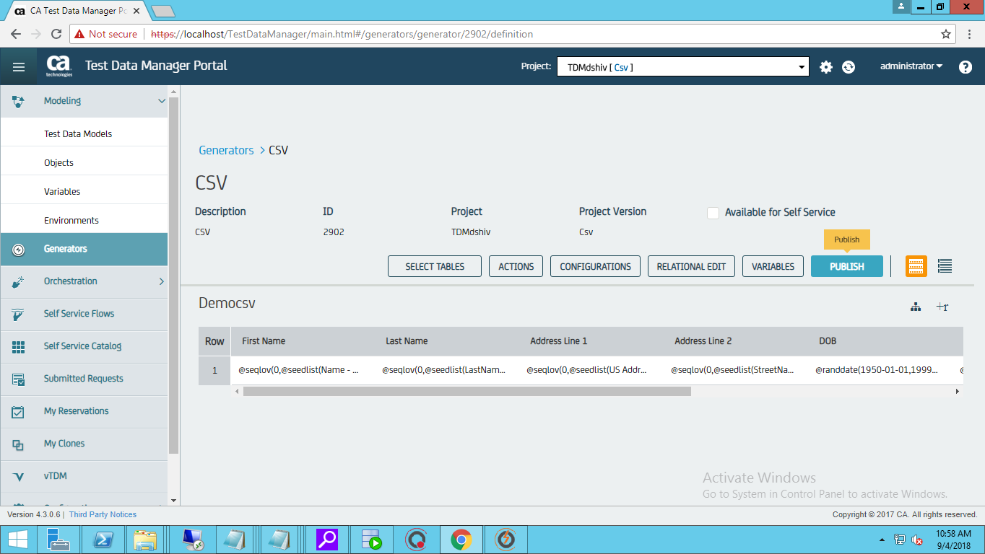

* Select the file type and the Repeat count

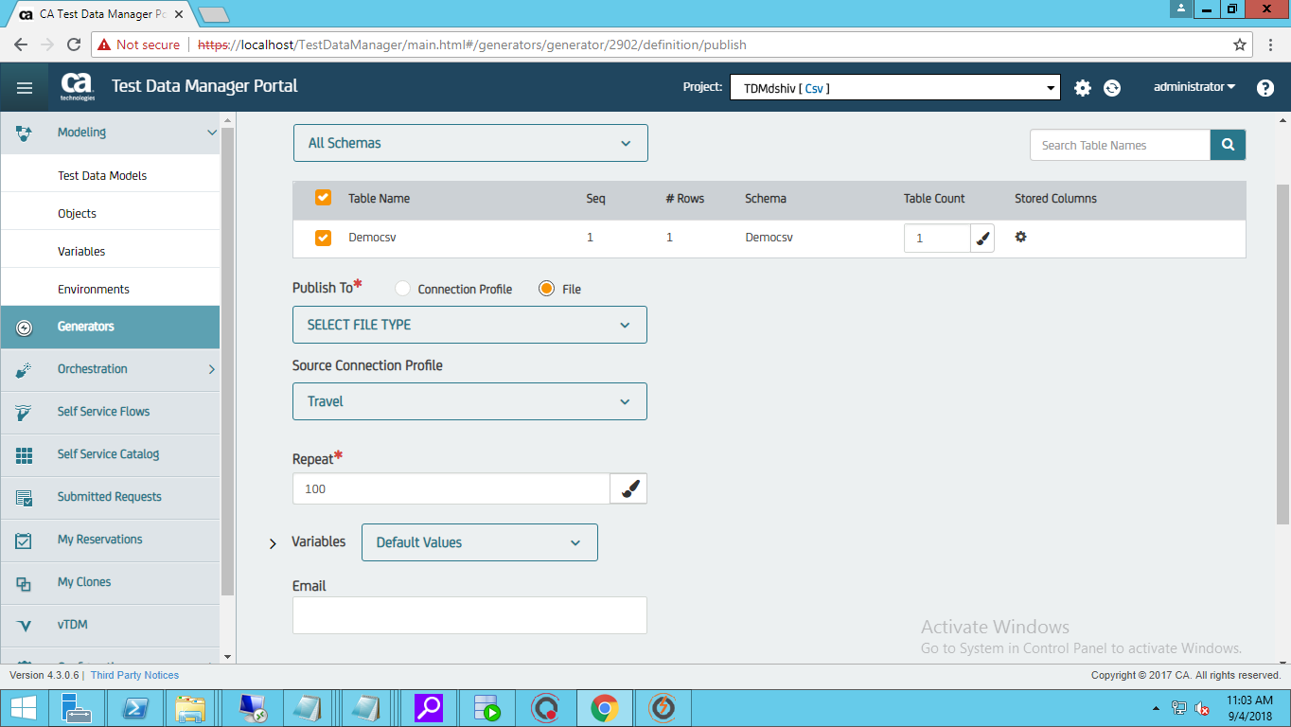

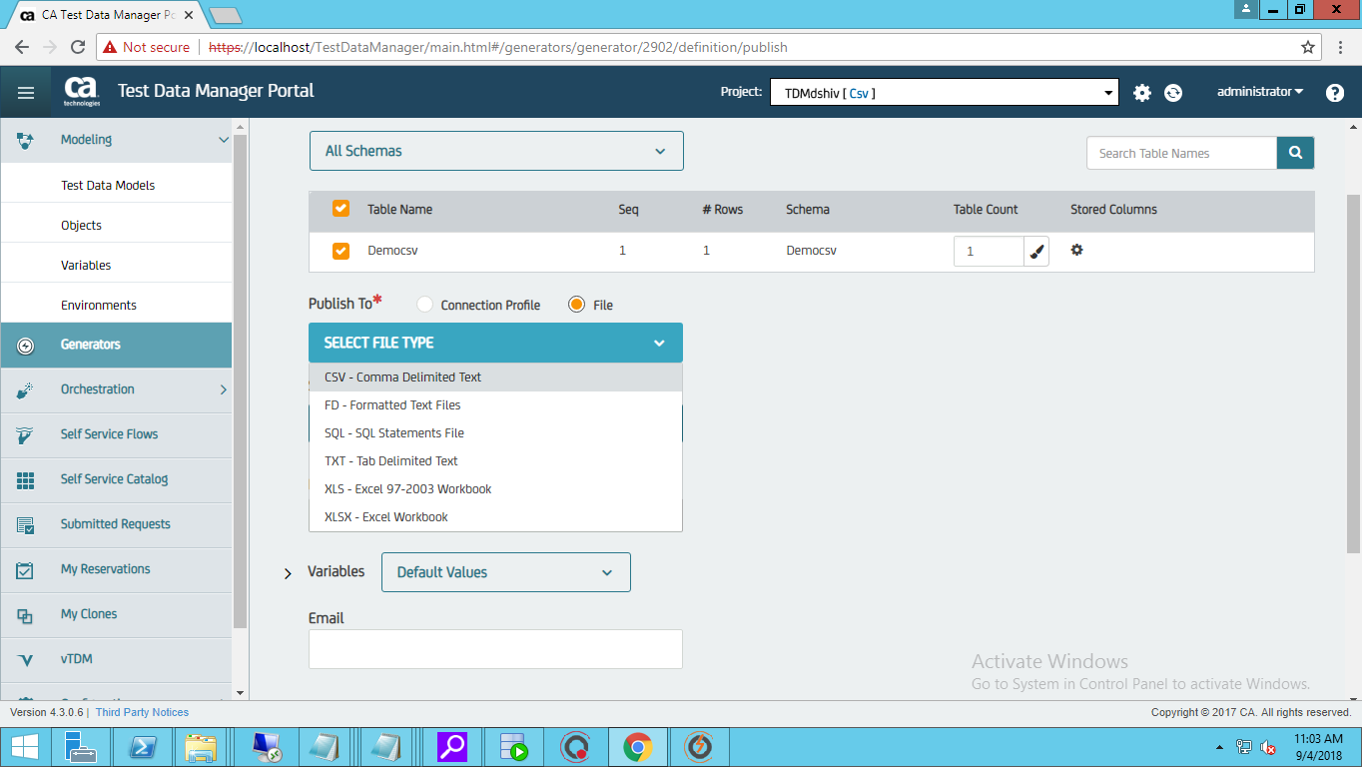

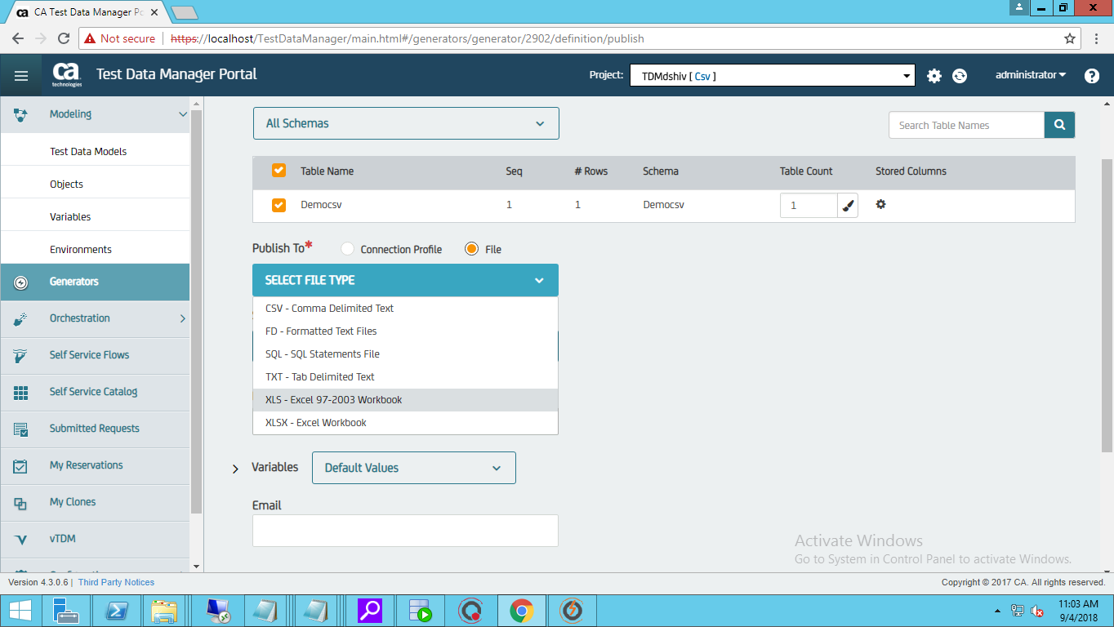

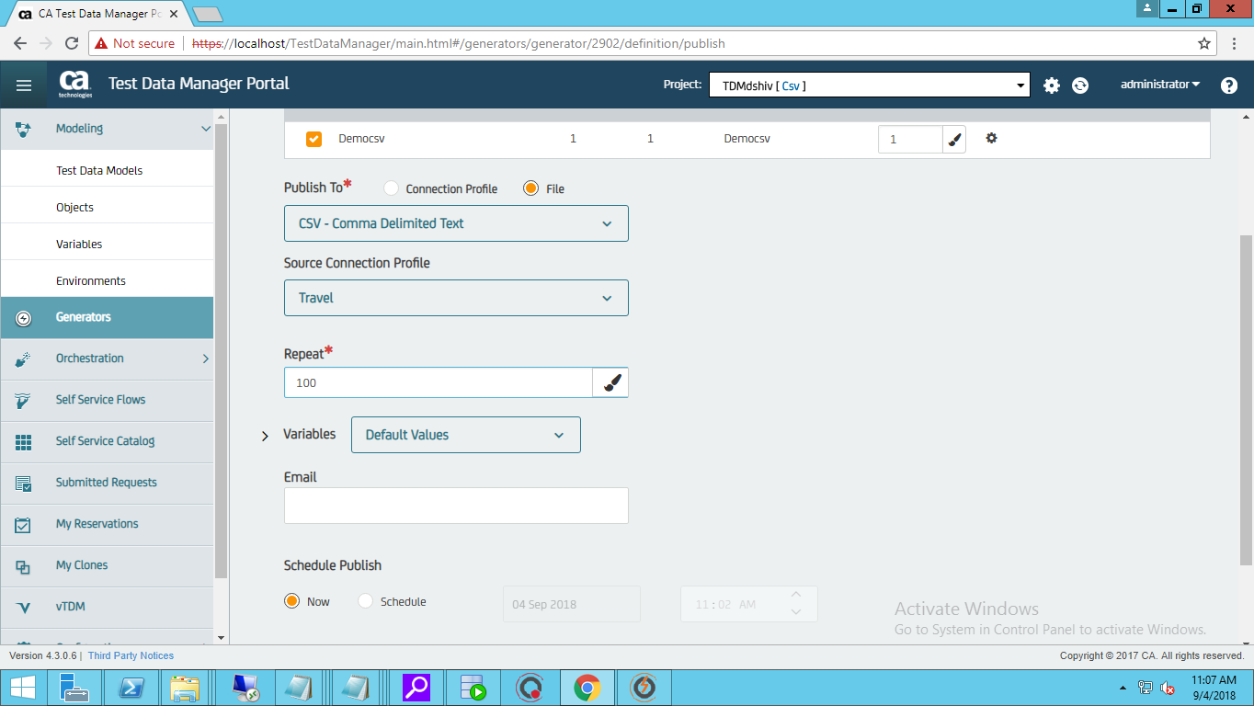

* Click On Publish on Choosing the required options

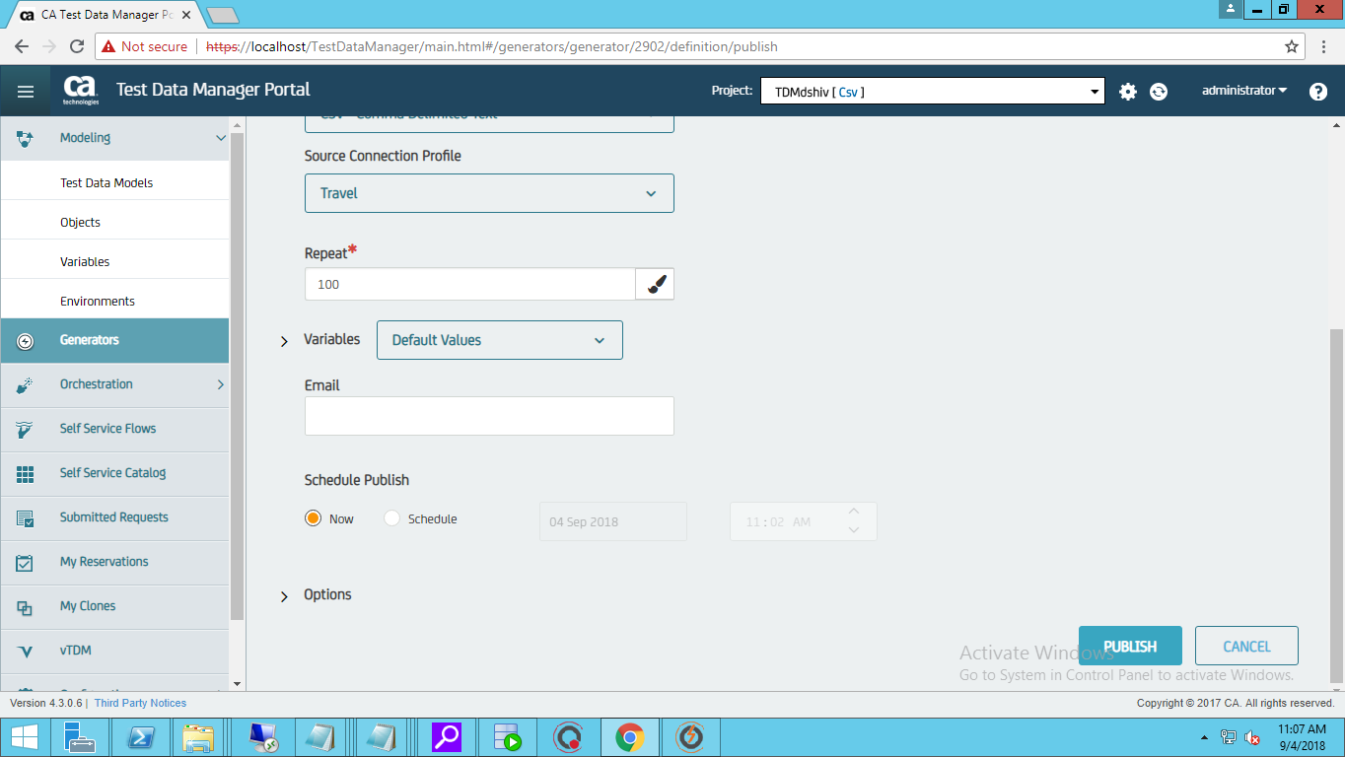

* On publihing we will get a Success Message with a Request ID, Click on the request ID to download the file **OR**
* You can see the Jobs run from Submitted Requests🡪Generators

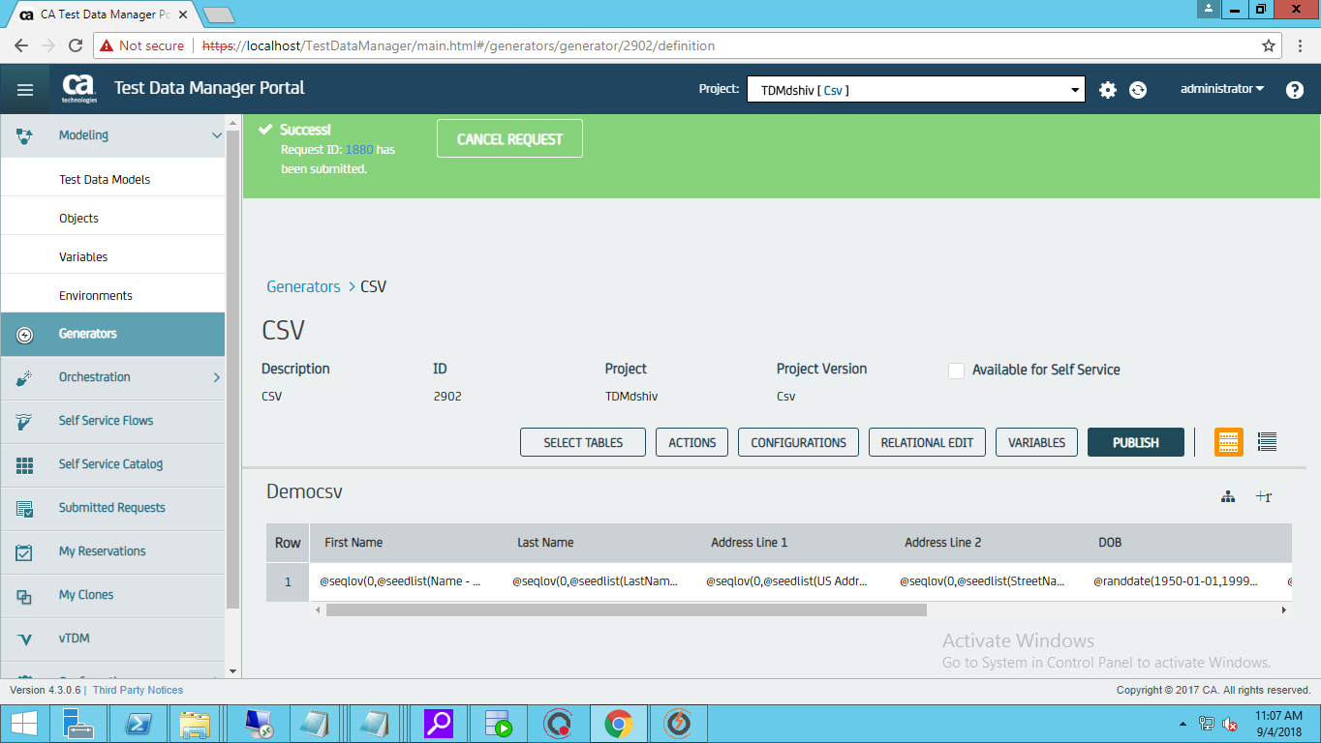

* Click on the recent JOB Run ID and Download the file

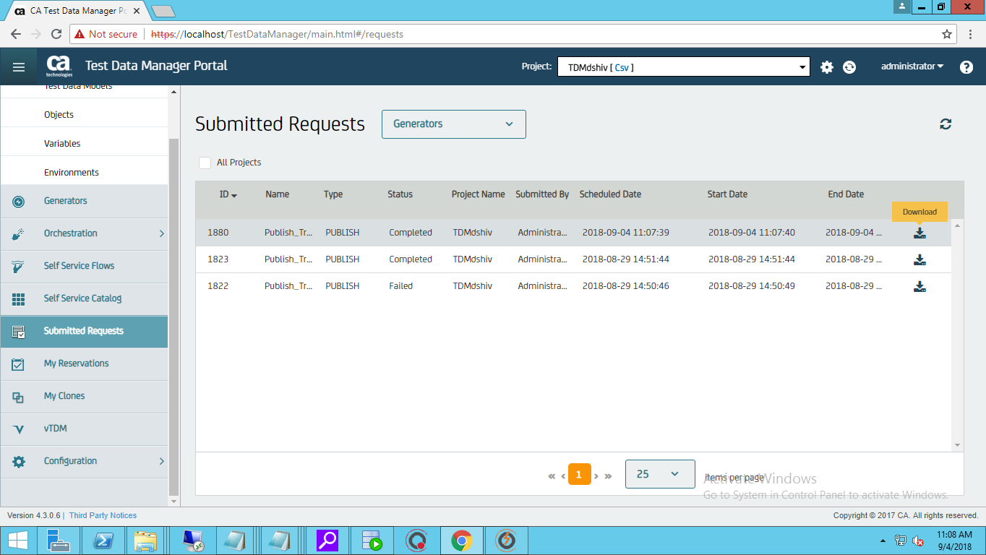

* Save the file

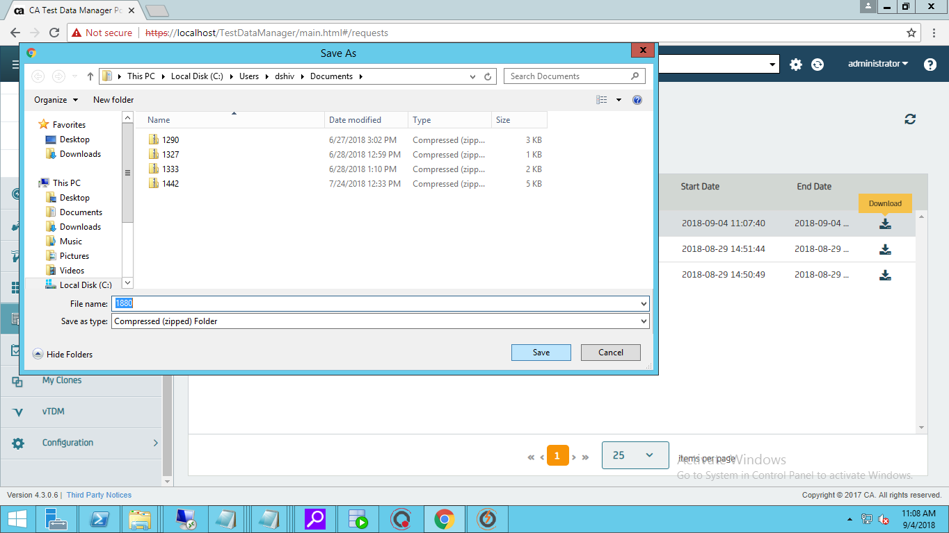

* You will be able to see the generated CSV/Excel file in the desired location

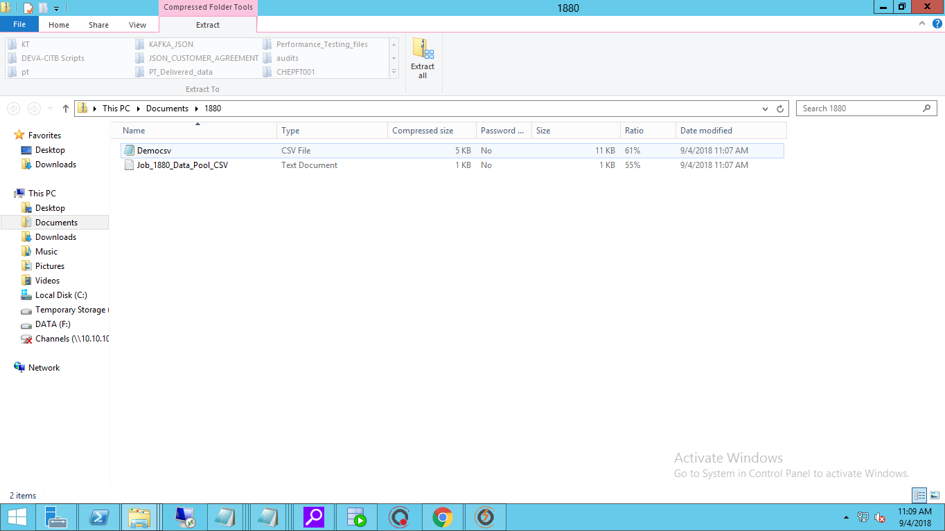

* **END RESULT**: 100 rows of Synthetic data generated in a CSV file.

